VALUATION OF THE COMMON STOCK OF:
CLIENT LOGO HERE (WHITE BACKGROUND)

xyz Corp
– DRAFT D1 REPORT –

Valuation Date: May 6, 2005 Report Date: September 3, 2026

Privileged and Confidential
NOT FOR DISTRIBUTION

1 Engagement Overview 4
1.1 Purpose and Scope of Valuation 4
1.2 Approach to Valuation 5
1.3 Limiting Conditions 7
1.4 Summary of Findings 7
2 Company Overview 8
2.1 Company Overview 8
2.2 Management Team 8
2.3 Financial Overview 8
2.4 Capitalization Structure 9
3 Economic Overview 10
4 Industry Overview 15
5 Valuation Theory and Considerations 16
5.1 Determining Stockholders’ Equity Value 16
5.2 Equity Value Allocation 19
5.3 Premiums and Discounts 21
6 Valuation Analysis 23
6.1 Approaches Considered and Applied 23
6.2 Income Approach Analysis 23
6.3 Market Approach Analysis 34
6.4 Cost Approach Analysis 41
6.5 Pass-thru Entity Premium NOT APPLIED TO CONTROLLING INTEREST 43
6.6 Selection of Methodology and Weighting 45
6.7 Allocation of Equity 45
6.8 Discount for Lack of Marketability 48
6.9 Consideration of Recent Transactions 49
6.10 Final Value 51
7 Summary and Results 52
Statement of Limiting Conditions 53
Certification 55
APPENDIX A: WEIGHTED AVERAGE COST OF CAPITAL 57
APPENDIX B: CAPEX/DEPRECIATION SCHEDULE 58
APPENDIX C: CALCULATION OF NOL 59
APPENDIX D: GUIDELINE COMPANIES – BUSINESS DESCRIPTIONS 60
APPENDIX E: GUIDELINE COMPANIES – FINANCIAL DATA 61
APPENDIX F: GPC MULTIPLES ADJUSTMENT 62
APPENDIX G: VOLATILITY 63
APPENDIX H: GUIDELINE TRANSACTIONS 65
APPENDIX I: TRANSACTION MULTIPLES ADJUSTMENT 66
APPENDIX J: DISCOUNT FOR LACK OF CONTROL 67
APPENDIX K: DISCOUNT FOR LACK OF MARKETABILITY 72
APPENDIX L: SOURCES OF INFORMATION 75

September 3, 2026

Contact Name
Title
Full Legal Name incl. d/b/a
Street Address
City, ST 00000

Re: Valuation of FULL LEGAL NAME incl. d/b/a as of May 6, 2005

Dear Mr./Mrs./Ms./Miss/Messrs./Mses. X,

At your request and pursuant to our engagement agreement, we have prepared and enclosed herewith our appraisal report of FULL LEGAL NAME incl. d/b/a (“xyz Corp,” or the “Company”) as of May 6, 2005 (the “Valuation Date”). The purpose of this valuation is to establish the fair market value as of the Valuation Date of one share of the Company’s common stock for the purposes of financial statement preparation and reporting under generally accepted accounting principles. This valuation opinion may be used for compliance purposes in conjunction with Internal Revenue Code (“IRC”) section 409A. It is anticipated that this valuation will be used to assist the Board of Directors of the Company in determining the potential strike price of options to be used on or subsequent to the date of the appraisal. It is our understanding that the valuation requirements for the intended use require an analysis of the per-share value of the chosen equity on a closely held, minority, and non-marketable basis.

xyz Corp is a closely held company without a publicly traded market. As such, the objective of this valuation is not to determine the price or fair market value at which a controlling interest in the Company would sell as if publicly traded. Rather, the objective is to quantify the fair market value of an ownership interest in xyz Corp, as a closely held entity, on a minority basis.

The standard of value relied on in this report is “fair market value,” defined by IRS Revenue Ruling (“RR”) 59-60 as “the price at which the property would change hands between a willing buyer and a willing seller when the former is not under any compulsion to buy and the latter is not under any compulsion to sell, both parties having reasonable knowledge of relevant facts.” RR 59-60 also states, “that the hypothetical buyer and seller are assumed to be able, as well as willing, to trade and to be well informed about the property and the market for such property.”

For the purposes of this engagement, Oxford Valuation Partners has assumed that fair market value is equivalent to “fair value,” which is defined as “the price that would be received to sell an asset or paid to transfer a liability in an orderly transaction between market participants at the measurement date.”

Users of this valuation report should be aware that business valuations are based on asset values and future earnings potential that may or may not materialize. Therefore, the actual results achieved and/or asset values obtained will vary from the forecasts used in this report, and the variations may be material.

In our opinion, based on our study and analysis and the assumptions and limiting conditions as described in this report, and taking into account the Company’s fully diluted shares outstanding as of the Valuation Date, we have concluded that the fair market value of xyz Corp’s common shares on a closely held, minority, and non-marketable basis as of the Valuation Date is:

Per common share: [insufficient inputs]

This letter and report are to be distributed only in their entirety and are intended and restricted for use by the management of xyz Corp and their representatives (“Management”) relative to the aforementioned purpose. This report is not to be copied or made available to any persons without the express written consent of Oxford Valuation Partners.

We appreciate the opportunity to provide valuation services to xyz Corp. Our valuation is subject to the attached Statement of Limiting Conditions. Should you require any further information, please contact us at 212-464-7178.

Respectfully submitted,

Oxford Valuation Partners, Inc.
info@oxfordvp.com

September 3, 2026

- Engagement Overview
  - Purpose and Scope of Valuation
Oxford Valuation Partners has been retained by the Company and has prepared this report for the purpose of expressing its opinion as to the fair market value of the Company’s common shares on a closely held, minority, and non-marketable basis as of the Valuation Date. This report is intended to present an objective, unbiased opinion of value for the exclusive purpose mentioned previously.

It is a restricted valuation appraisal intended only for the purposes indicated herein. A restricted report is limited in scope. Specifically, our report may not be used in any filings with the Securities and Exchange Commission (“SEC”). In the event that the SEC requests a copy of this valuation report, the Company and Oxford Valuation Partners agree that Oxford Valuation Partners will provide a full scope, self-contained valuation report for submission to the SEC. The Company may not require Oxford Valuation Partners to reconcile this restricted report to any final formal report that may be prepared for submission to the SEC.

Neither this letter nor the attached valuation report may be referred to or quoted in any prospectus, loan agreement, or other agreement or document given to third parties without our prior written consent. This report is not designed or intended to be a document suitable for use in selling this business to outside individuals or other entities which may be uninformed about the entity being valued. Because this report is to be used for Management purposes, it may not contain sufficient descriptive information to satisfy an uninformed prospective buyer of the subject Company. It is also not designed to adequately portray all the desirable qualities of the business, which should be addressed in an offering document designed for a potential buyer of the business.

In this appraisal, we have considered the Company’s equity and capitalization structure, incorporating guidance from Management regarding authorized but unissued equity instruments that are expected to be issued in the near term. For this purpose, we have defined “near term” as the sooner of 12 months or the date of an expected future financing as proxies for events that would drive a review of the Company’s valuation.
A restricted appraisal report is intended solely for the use of Management. It should be shared with those of your advisors who have the requisite knowledge to understand the risks, opportunities, and the valuation theories and analyses discussed and applied in this situation, since this report may not be understood properly by other readers without additional information contained in the work files of Oxford Valuation Partners. This report should not be distributed to third parties without the express knowledge and written consent of Oxford Valuation Partners.
  - Approach to Valuation
This valuation engagement was conducted in accordance with the AICPA’s “Statement on Standards for Valuation Services No. 1- Valuation of a Business, Business Ownership Interest, or Intangible Assets” (“SVSS No. 1”), the AICPA’s practice aid, Valuation of Privately-Held Company Equity Securities Issued as Compensation (the “Practice Aid”), and with Internal Revenue Manual Business Valuation Guidelines. The standards deal with the procedures and reporting requirements to be followed in the preparation of an appraisal, analysis, or opinion.

In our determination of value, we have considered certain factors set forth by the Internal Revenue Service in RR 59-60 for the valuation of security interests in closely held businesses. These factors include:
- The nature of the business and the history of the enterprise from its inception.
- The general economic outlook and the condition and outlook of the specific industry in particular.
- The book value of the stock and the financial condition of the business.
- The size of the block of equity interest to be valued.
- The market price of the stock of corporations engaged in the same or similar line of business, having their stock actively traded in a free and open market, either in an exchange or over the counter.

We studied, analyzed, and interpreted both internal and external factors that could influence the value of xyz Corp. Internal factors included the Company’s financial position, results of operations, and Management, as well as the size and marketability of the interest being valued. External factors included, among other things, the status of the industry and the Company’s position relative to the industry.
In performing our work, our investigation and analysis included, but was not necessarily limited to, the following steps:
- Interviews with Management concerning the assets, financial and operating history, forecasted future operations of the Company, the outlook for the Company and the industry sector in which it operates, the state of competition in its primary and adjacent markets, and the assumptions underlying any plans or estimates as well as risk factors that could affect future performance.
- Analysis of audited and (REMOVE “AUDITED AND”) IF NO AUDITED FINANCIALS PROVIDED) unaudited historical and forecast financial statements and other financial and operational data concerning the Company.
- Review of corporate documents, including but not limited to, the articles of incorporation or other descriptions of the preferred shareholder rights and capitalization summary of preferred and common shares, options, and warrants.
- Independent research concerning the Company, its financial and operating history, the nature of its products and services, and its competitive position in the marketplace.
- Independent research concerning the industry in which the Company operates.
- Research and analysis concerning comparable public companies and transactions involving comparable public and private companies.
- Independent research concerning the relevant economic conditions and outlook for the United States economy.
- Valuation analysis utilizing appropriate methodologies from among the income approach, market approach, and asset approach.
- Allocation of value analysis utilizing appropriate methodologies from among the current value method, probability-weighted return method, and the option pricing method.
- Consideration of premiums and/or discounts such as control premiums, minority interest discounts, voting control adjustments, and lack of marketability discounts.

The approaches and methodologies used in our work did not comprise an examination in accordance with generally accepted auditing standards (“GAAS”). The objective of a GAAS examination is to express an opinion regarding the fair presentation of historical or prospective financial statements or other financial information presented in accordance with generally accepted accounting principles (“GAAP”). Since we did not perform an examination in accordance with GAAS, we express no opinion and accept no responsibility for the accuracy and completeness of the financial information or other data provided to us by others. We assume that the financial and other information provided to us is accurate and complete, and we have relied upon this information in performing our valuation.

In conducting this valuation engagement, we considered all material information required to reach a reasoned conclusion as to the value of the Company’s common stock, given its stage of development and operating context, and in accordance with prevailing national standards of appraisal as set forth by the AICPA and other national bodies.

Any material events that took place after the Valuation Date and prior to the Report Date, which were reasonably knowable at the time of the Valuation Date, have been taken into consideration in our analysis in accordance with the guidelines established in the Practice Aid.
  - Limiting Conditions
We urge readers to study the Statement of Limiting Conditions which is included as part of this report. Additionally, numerous assumptions are included throughout this report; therefore, readers should study the entire report in order to obtain an understanding of the value estimate contained herein.
  - Summary of Findings
In our opinion, based on our study and analysis and the assumptions and limiting conditions as described in this report, and taking into account the Company’s fully diluted shares outstanding as of the Valuation Date, we have concluded that the fair market value of one share of xyz Corp’s common stock on a closely held, minority, and non-marketable basis as of the Valuation Date is:

Per common share: [insufficient inputs]

- Company Overview
  - Description of the Business
xyz Corp is a Delaware company founded in 2012 with business headquarters in New York.

PLACE TEXT HERE
  - Management Team
The Company’s management team consists of:
- Name – Title.
- Name – Title.
- Name – Title.
- Name – Title.
  - Financial Overview
    - Balance Sheet
The Company’s historical balance sheet information is presented in the table below. All information is based on the financial statements provided by Management.

Period

If necessary, provide details here regarding anything we did which may cause the information above to be different than what was provided. This would include the addition of cash/debt/equity which occurred AFTER the date shown on the balance sheet but was a known and knowable event (i.e., a financing round, new debt, etc.) or any other adjustments WE made to the data provided.
    - Income Statement
The Company’s historical income statements are presented in the table below. All information is based on the financial statements provided by Management.

Period
  - Capitalization Structure
As of the Valuation Date, the Company’s capital structure is comprised of common stock, preferred stock, options, common warrants, and preferred warrants.

Class | Shares | Aggregate LP / avg. strike
Preferred | 0 | $0.00
Common | 0 | —
Options / pool | 0 | $0.00
Fully diluted | 0

As previously discussed, and in keeping with AICPA guidelines, the cap table includes unissued options that Management expects to issue in the near term. In addition, we have….this is where we detail what adjustments, if any, we have made to the cap table provided and why (more shares will be issued, new round expected, etc.).

The rights and preferences of xyz Corp’s share classes are summarized below:
- Dividend Rights: There are no cumulative dividends on the preferred shares OR INSERT CUMULATIVE DIVIDEND RIGHTS ONLY.
- Liquidation Preference: Upon liquidation, dissolution, or winding up of the Company:
  - INSERT PREFERENCES
- MAKE SURE TO ANY OTHER RELEVANT RIGHTS/PREFERENCES SUCH AS REDEMPTIONS, MANDATORY CONVERSIONS, CAPS, ETC.
- Anti-dilution: Anti-dilution is calculated using the broad-based weighted average method.

- Economic Overview
  - Global Overview
Global economic activity continues to soften amid the effects of tight monetary policies, restrictive financial conditions, and weak global trade growth. After a sharp slowdown in 2022 and another decline last year, global output growth is set to edge down in 2024, marking the third consecutive year of deceleration. The recent conflict in the Middle East has heightened geopolitical risks and raised uncertainty in commodity markets, with potential adverse implications for global growth. This comes while the world economy continues to cope with the lingering effects of the overlapping shocks of the past four years—the COVID-19 pandemic, the Russian Federation’s invasion of Ukraine, and the rise in inflation and subsequent sharp tightening of global monetary conditions.

Near-term prospects are diverging. Growth in advanced economies as a whole and in China is projected to slow in 2024 to well below its 2010-19 average pace. Meanwhile, aggregate growth is set to improve in emerging markets and developing economies (“EMDEs”) with strong credit ratings, remaining close to pre-pandemic average rates. Although overall growth is also expected to firm somewhat from its 2023 low in EMDEs with weak credit ratings, the outlook for many such countries remains precarious, given elevated debt and financing costs and idiosyncratic headwinds such as conflict.

Global headline and core inflation have continued to decline from 2022 peaks. Nonetheless, inflation remains above target in most advanced economies and about half of inflation-targeting EMDEs. Global inflation is projected to remain above its 2015-19 average beyond 2024. Monetary tightening in advanced economies is concluding, but real policy interest rates are expected to remain elevated for some time as inflation returns to target only gradually. This will keep the stance of advanced-economy monetary policies restrictive in the near term, following the largest and fastest increase in U.S. real policy rates since the early 1980s.

Against this backdrop, global growth is estimated to have weakened last year to 2.6 percent. Although this is 0.5 percentage points higher than last June’s forecast, it is mainly due to better-than-expected growth in the United States. Global growth is forecast to slow again, to 2.4 percent in 2024. This deceleration reflects softening labor markets, reduced savings buffers, waning pent-up demand for services, the lagged effects of monetary tightening, and fiscal consolidation.

Over 2020-24, the forecast entails the weakest start to a decade for global growth since the 1990s—another period characterized by geopolitical strains and a global recession. Global growth is projected to pick up to 2.7 percent in 2025, as inflation continues to slow, interest rates decline, and trade growth firms. Advanced-economy growth is set to bottom out at 1.2 percent in 2024 as growth in the United States slows, while euro area growth, which was feeble last year, picks up slightly as lower inflation boosts real wages. In 2025, growth in advanced economies is forecast to pick up to 1.6 percent as the euro area continues to recover and U.S. growth edges up toward its long-term trend rate amid declining inflation and more supportive monetary policy.

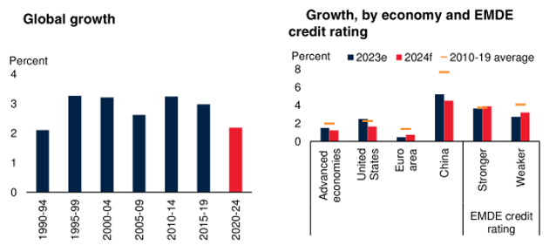

The weak global growth outlook and the various downside risks highlight the challenges facing policymakers around the world. At the global level, coordinated improvements in debt relief, especially for the poorest countries, will be necessary to free up resources for growth-enhancing investments in human and physical capital. Otherwise, mounting debt-service costs and slow progress in debt restructuring could exacerbate the difficulties facing many EMDEs. Already, about half of LICs and many middle-income countries are either in, or at high risk of, debt distress. Enhanced international cooperation is also required to tackle the existential threat of climate change, including by accelerating the clean energy transition, helping countries improve energy security and affordability, and incentivizing the investments needed to pursue a path toward resilient, low-carbon growth. In addition, the global community needs to guard against the fragmentation of trade and investment networks, including by prioritizing a rules-based international trading system and expanding trade agreements. Furthermore, global cooperation is critical to address the pressing issues of mounting food insecurity and conflict.

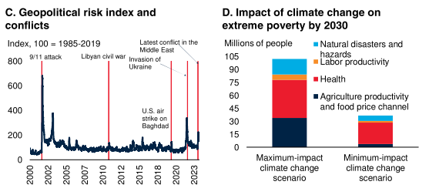
    - Global Context
The global context remains challenging. Global trade growth has been exceptionally weak because of subdued global demand, the continued post-pandemic rotation of consumption from goods toward services, and more restrictive trade policies. Notwithstanding recent volatility, prices of most commodities have fallen back from their 2022 peaks but remain above pre-pandemic levels. This moderation has contributed to a decline in global headline inﬂation. Core inﬂation, however, has been more persistent, especially in some advanced economies where labor markets remain tight. This suggests that policy interest rates in advanced economies will decline only gradually, contributing to higher longer-term market rates than those that prevailed before the pandemic. EMDE ﬁnancial conditions remain restrictive, with less creditworthy sovereigns facing greater ﬁnancial strains, as reﬂected in sharp currency depreciations and capital outﬂows.

Global trade in goods and services was virtually flat in 2023, growing by an estimated 0.2 percent—the slowest expansion outside global recessions in the past 50 years. Goods trade contracted last year, reflecting declines in key advanced economies and deceleration in EMDEs, and mirroring the sharp slowdown in the growth of global industrial production. This marked the first sustained contraction in goods trade outside a global recession in the past 20 years. The global trade growth forecast for 2024 has been revised down by 0.5 percentage points since June, reflecting weaker-than-expected growth in China and in global investment. As a result, the recovery of trade now projected for 2021-24 is the weakest following a global recession in the past half-century. Geopolitical uncertainty, especially in light of ongoing armed conflicts, and the possibility of a more protracted slowdown in China pose downside risks to the trade outlook. Another downside risk arises from the possibility of further measures to restrict international trade.

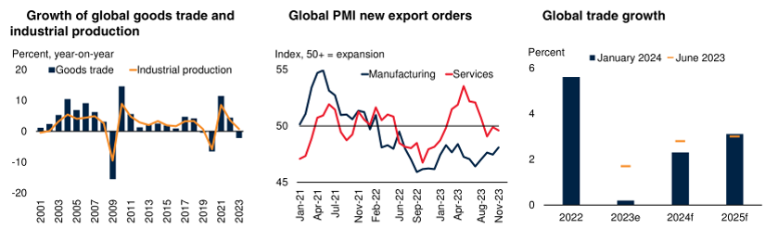

Global headline consumer price inflation declined substantially in 2023. Moderating energy and food price inflation, along with slowing consumer demand for goods and the recovery of global supply chains, exerted significant downward pressure on goods inflation. Nonetheless, inflation remains above targets in most advanced economies and about half of inflation-targeting EMDEs. In the major advanced economies, the rotation of demand from goods to services continued. Declining goods inflation amid easing import prices was partly offset, however, by persistent services inflation tied to tight domestic labor markets. As a result, core inflation, which surged less than headline inflation in 2021-22, has also declined less since its 2022 peak.

The decline in core inflation has proceeded under markedly different growth conditions across countries. In the United States, disinflation has occurred alongside resilient activity and low unemployment, thanks partly to increasing labor supply, improving supply chains, and falling oil prices. The decline in the euro area inflation was accompanied by weak growth, reflecting the negative supply shocks from earlier sharp energy price increases. In most EMDEs, headline and core inflation receded last year as growth weakened. Nevertheless, in countries facing financial stress, inflation remained very high, in association with currency depreciations.

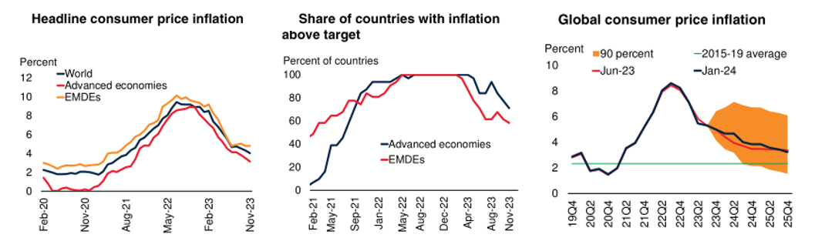

In 2024-25, global inflation is expected to decline further, underpinned by the projected weakness in global demand growth and slightly lower commodity prices. Subdued demand reflects the effects of tight monetary and credit conditions and softening labor markets. Thus, global headline inflation, on a year-on-year basis, is forecast to recede to 3.7 percent in 2024 and 3.4 percent in 2025—still above the pre-pandemic (2015-19) average but closer to central bank inflation targets. Surveys of inflation expectations similarly suggest a steady decline in inflation, but to levels in 2024 that are still higher than pre-pandemic averages. Consensus forecasts indicate lower inflation this year than last in 85 percent of EMDEs.
    - Global Outlook
Global growth is projected to edge down from an estimated 2.6 percent in 2023 to 2.4 percent in 2024, marking the third consecutive year of deceleration. Relative to last June’s projections, the forecast for 2023 has been revised up by 0.5 percentage point, mainly reflecting the strength of the U.S. economy, whereas that for 2024 is unchanged, with a sizable upgrade to U.S. growth accompanied by a downward revision to euro area activity. Growth is forecast to pick up slightly to 2.7 percent in 2025, owing mainly to firming advanced-economy activity, as inflation continues to soften and interest rates decline. EMDE growth is projected to be virtually unchanged, at about 3.9 percent a year through 2024-25, with growth in China set to slow while that in other EMDEs picks up. EMDE growth is expected to be supported by a modest firming of export and investment growth. However, it is still expected to be weaker than its average pace over the past two decades, though broadly in line with estimated potential growth.

While the moderation in commodity prices in 2023 contributed to a decline in global headline inflation, services inflation has proved more persistent, especially in advanced economies, reflecting still-tight labor markets. As such, the easing of advanced-economy policy interest rates will likely proceed at a measured pace, implying a continued period of elevated real interest rates. This will be particularly challenging for vulnerable EMDEs with lower sovereign creditworthiness. For most such countries, dollar-denominated bond yields have moved well above nominal GDP growth (in U.S. dollars), squeezing fiscal space.

Notwithstanding the projected firming of global growth, the outlook remains subdued by historical standards: the forecast for global growth over 2024-25, about 2.5 percent a year on average, is 0.6 percentage point below the 2010-19 average rate. This partly reflects the lingering effects of recent shocks, including the pandemic, the invasion of Ukraine, the sharp increase in inflation, and the associated tightening of global financial conditions. Another contributing factor is the weakening of trade growth, partly attributed to more inward-looking policies. However, the subdued expected pace of global growth also reflects a longer-term downtrend in potential growth. The structural slowdown in EMDEs, and especially in China, is due to several forces: labor force growth has slowed because of demographic shifts; productivity growth has weakened as growth dividends from improvements in health and education have diminished, and as some EMDEs have moved closer to productivity frontiers; and the pace of capital accumulation has declined, in part as a result of debt overhangs.

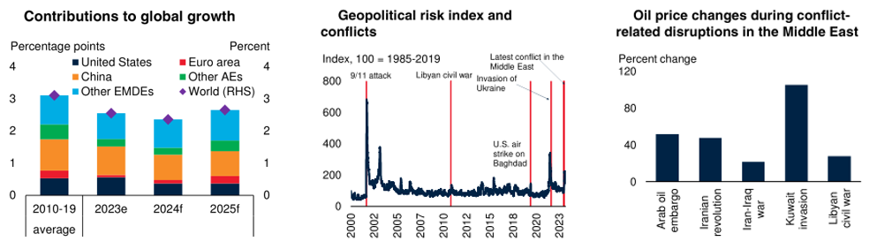

Risks to the global growth outlook have become somewhat more balanced since last June, as banking system stress in advanced economies has receded and inflation has declined. Nevertheless, risks remain tilted to the downside. The possibility of an intensification of the conflict in the Middle East represents a major downside risk. This, or rising geopolitical tensions elsewhere, could have adverse impacts through commodity markets, trade and financial linkages, uncertainty, and confidence. Weak growth, elevated debt, and still-high interest rates heighten the risk of financial stress, especially in the more vulnerable EMDEs. Higher or more persistent inflation may require a longer-than-assumed period of tight monetary policy. Subdued recent activity in China raises the possibility of slower-than-expected growth, which would have adverse global spillovers. Trade fragmentation and climate-related disasters could also result in weaker growth in the near and longer terms. On the upside, recent surprisingly strong economic activity in the United States, along with declining inflation, points to the possibility that growth may be stronger than projected, perhaps as a result of improved supply conditions.
  - The US Economy
Real GDP is projected to grow by 2.4 percent in 2023, 1.5 percent in 2024, and 1.7 percent in 2025. Private consumption and investment growth is expected to moderate in response to the effects of tighter monetary and financial conditions. Employment growth will slow further in response to weaker demand, and the unemployment rate will continue to edge up through the first half of 2024. Inflation will decline, allowing for monetary policy easing in the second half of 2024 and a recovery of domestic demand growth in 2025. The outlook could worsen if the effects of tighter policy rates are stronger than assumed or lead to financial stress. A stronger decline in inflation combined with resilient employment could lead to a greater easing of financial conditions and an improved growth outlook.

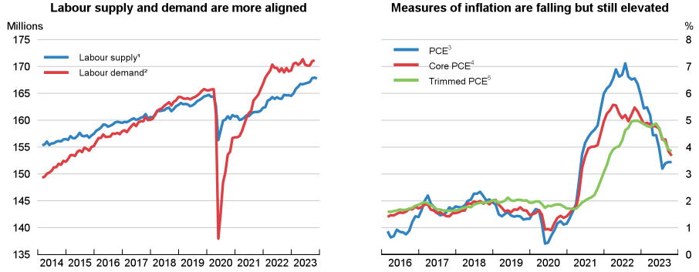
Monetary policy will remain restrictive in the near term, exerting downward pressure on inflation while still allowing for economic growth, but will ease gradually from late 2024. The budget deficit will narrow somewhat in 2024 but remain large, while long-term fiscal pressures are mounting. Adopting a framework to improve the sustainability of public finances will help produce a more sustainable and inclusive economic future, while enhancing macroeconomic stability.
    - Growth Has Remained Resilient and the Labor Market Has Eased
Real GDP growth remained robust in the first half of 2023 and strengthened in the third quarter to an annualized rate of 4.9 percent. After a period where labor demand growth outpaced labor supply, supply and demand are now more aligned, and job growth has continued at a moderate but slowing pace in 2023. The unemployment rate has edged up in recent months but remains low by historical standards. Measures of inflation have decreased since the beginning of 2023, though headline inflation has recently risen again due to higher energy prices. Still, core and headline inflation are elevated, with housing and services inflation putting upward pressure on core inflation.
International developments were supportive of growth in the first half of 2023, and net exports contributed positively to GDP growth, even as the dollar-effective exchange rate remained elevated. Petroleum exports have risen to record levels in 2023. However, bilateral trade with China fell in the first half of the year. Exports to China are roughly flat but imports from China fell by 25 percent from a year earlier.
    - Monetary and Fiscal Policy Will Exert a Contractionary Influence in 2024
The federal funds rate is currently in the 5¼-5½ percent range, which is near the expected peak of the tightening cycle that began in 2022 and is likely to remain elevated until the second half of 2024 given the anticipated persistence of core inflation. Recent increases in the 10-year bond yield—and the pass-through to private rates—have further tightened financial conditions. The OECD projections assume that cuts in the federal funds rate will begin in the third quarter of 2024, after inflation has fallen closer to the 2 percent target. The federal funds rate is projected to fall to around 4 to 4¼ percent by the end of 2025 with the 10-year interest rate at a similar level.
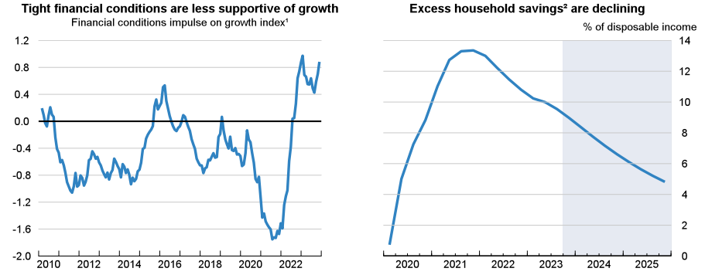
Fiscal policy is expected to tighten in 2024 after an unexpected fiscal expansion in 2023 and be broadly neutral in 2025. Though extraordinary support for households and businesses has mostly been unwound, the fiscal deficit increased in 2023 due to a combination of lower-than-expected tax receipts and higher-than-expected spending on mandatory social programs. Government net lending as a share of GDP is projected to be 7 percent in 2024 and gross debt will increase to 124 percent of GDP in 2024 and rise further in 2025.
    - Growth Will Be Sluggish Before Recovering
Real GDP growth will slow to 1.5 percent in 2024 before increasing to 1.7 percent in 2025. More restrictive financial conditions due to tighter monetary policy will act as a headwind. The supportive effects of earlier rising asset prices and accumulated excess household savings are fading. Housing and business investment will slow through the first half of 2024. As demand slows, employment growth will ease further, and the unemployment rate will edge up. Inflation will continue to decline as core inflation eases due to a slowing economy and as supply conditions ease further. As inflation subsides and monetary policy eases, consumption and investment growth are projected to pick up in the second half of 2024 and into 2025.
The outlook could surprise on the downside if the effects of tight financial conditions prove to be stronger than anticipated or if core inflation remains elevated, delaying any potential monetary policy easing. Banking sector stress in early 2023 has subsided, but volatility in bond markets may prove to be a stronger impediment to growth. In the near term, a potential government shutdown would be a drag on growth until its resolution. However, the outlook could surprise on the upside if the labor market loosening continues without a rise in unemployment and declines in inflation continue unabated.
    - Policy Should Focus on Durably Reducing Inflation and Narrowing the Deficit
Monetary policy should remain tight until the Federal Reserve’s inflation objectives are durably achieved while continuing to assess the impact on real activity. Financial stability risks arising from the financial sector should continue to be closely monitored. Stronger efforts should be made to narrow the large budget deficit and put the government debt ratio on a downward path to more sustainable levels. Population aging will push future outlays higher, with increases in pension and health expenditures projected to rise by more than 3 percentage points of potential GDP by 2040. Adopting a solid medium-term focused framework to improve the sustainability of public finances would ease these pressures and create space for the funding of future productivity-enhancing projects, such as improvements to public digital infrastructure and policies to achieve the climate transition.

- Industry Overview
xyz Corp operates in the INDUSTRY with a focus as DESCRIPTION OF BUSINESS. An analysis of the space provides an understanding of the Company relative to its competitors.

PLACE TEXT HERE – A COUPLE OF PARAGRAPHS, NO % SIGNS (WRITE “PERCENT”), AND INSERT AN IMAGE OR TWO THAT ARE RELEVANT TO WHAT YOU WRITE.

- Valuation Theory and Considerations
  - Determining Stockholders’ Equity Value
In developing a valuation conclusion, appraisers should analyze the relevant information necessary to accomplish the assignment, including:
- The nature of the business and the history of the enterprise from its inception.
- The economic outlook in general and the condition and outlook of the specific industry in particular.
- The book value of the stock or interest and the financial condition of the business.
- The earning capacity of the company.
- The dividend-paying capacity of the company.
- The size of the block of stock to be valued.
- The market price of stocks or interests of corporations or entities engaged in the same or a similar line of business having their stocks or interests actively traded in a free and open market, either on an exchange or over the counter.
- Other relevant information.

The appraisal of any asset or collection of assets can be broadly classified into one of three generally accepted approaches – the income, market, and asset-based approaches. The IRS has noted that “[p]rofessional judgment should be used to select the approach(es) ultimately used and the method(s) within such approach(es) that best indicate the value of the business interest.” The IRS has further laid out the following principles that should be followed in developing a valuation conclusion:
- Historical financial statements should be analyzed and, if necessary, adjusted to reflect the appropriate asset value, income, cash flows and/or benefit stream, as applicable, to be consistent with the valuation methodologies selected by the valuator.
- The valuation professional should select the appropriate benefit stream, such as pre-tax or after-tax income and/or cash flows, and select appropriate discount rates, capitalization rates or multiples consistent with the benefit stream selected within the relevant valuation methodology.
- The valuation professional will determine an appropriate discount and/or capitalization rate after taking into consideration all relevant factors such as:
- The nature of the business.
- The risk involved.
- The stability or irregularity of earnings.
- Other relevant factors.
- As appropriate for the assignment, and if not considered in the process of determining and weighting the indications of value provided by other procedures, the valuation professional should separately consider the following factors in reaching a final conclusion of value:
- Marketability, or lack thereof, considering the nature of the business, business ownership interest or security, the effect of relevant contractual and legal restrictions, and the condition of the markets.
- Ability of the appraised interest to control the operation, sale, or liquidation of the relevant business.
- Other levels of value considerations, such as the impact of strategic or synergistic contributions to value.
- Such other factors which, in the opinion of the valuator, are appropriate for consideration.

As is apparent from the guidelines noted above, the analyses involved in conducting a business valuation engagement offer significant discretion to the judgment of the appraiser in defining the appropriate methodologies to be employed in deriving indications of value. The following is an excerpt from section 6.2 of the American Society of Appraisers (“ASA”) Principles of Appraisal Practice:

The procedure and method for determining the particular value in question is a matter for the appraiser himself to determine – he cannot be held responsible for the result unless he has a free hand in selecting the process by which that result is to be obtained. However, good appraisal practice requires that the method selected be adequate for the purpose, embrace consideration of all the factors that have a bearing on the value, and be presented in a clear and logical manner.

The AICPA has developed the following guidelines on the same matter:

There are no “rules of thumb” or universal formulas that can reliably be used to determine the value of an enterprise…Each valuation is unique, and a final determination of value based on an assessment of different values obtained under the various methods requires the exercise of judgment. That judgment should include consideration of factors such as the relative applicability of the methods used given the nature of the industry and current market conditions; the quality, reliability, and verifiability of the data used in each methodology; the comparability of public enterprise or transaction data used in the analyses to the subject enterprise; and any additional considerations unique to the subject enterprise.

In order to arrive at our estimates of value, we considered the three generally accepted approaches to valuation – the income approach, the market approach, and the asset-based approach. The appraiser considers, but is not required to use, all three approaches.
    - The Market Approach
The market approach is based on the premise that an informed buyer would not pay more for an asset than the cost of an identical or similar asset. This approach references actual transactions in the equity of the enterprise being valued or transactions in similar enterprises that are traded on the public markets. In using transactions from similar enterprises, there are three primary methods. The first, often referred to as the Guideline Transactions Method, involves determining valuation multiples from sales of enterprises with similar financial and operating characteristics and applying those multiples to the subject enterprise. The second, often referred to as the Guideline Public Company Method, involves identifying and selecting publicly traded enterprises with financial and operating characteristics similar to the enterprise being valued. Once publicly traded enterprises are identified, valuation multiples can be derived, adjusted for comparability, and then applied to the subject enterprise to estimate the value of its equity or invested capital.

The AICPA has noted that a significant limitation of the market approach is that “true” comparables are unlikely to exist, particularly in valuing privately held enterprises. Another limitation arises if the enterprise being valued has no earnings or has immaterial revenue, as forecasts of financial statement amounts may then be highly speculative. A third method under the rubric of the market approach is the Guideline Venture Funding, or Backsolve, Method. This method uses information from the most recent round of venture capital/private equity financing to approximate an equity value for the company.
    - The Income Approach
The income approach is based on the premise that the value of a security or asset is the present value of the future earning capacity that is available for distribution to investors in the security or asset. To use the income approach, an analysis of a company’s revenues, expenses, capital expenditures, non-cash expenditures, and capital structure is made. The revenue analysis can include consideration of such things as units sold or production levels, average selling price, market dynamics, competitive pressures, price elasticity of demand, regulatory changes, or technological changes. Once these factors have been analyzed, revenues are then either projected for a discrete forecast period, typically five fiscal years, or normalized to represent future years. In the same way, expenses are either projected over a period of future years or normalized. The resulting forecasted or normalized income is then capitalized or discounted at an appropriate rate to determine the present value of the business.

Income method valuation methodologies include discounted cash flow and capitalized cash flow analyses. In the discounted cash flow method, future cash flows are discounted to their present value using an appropriate discount rate or required rate of return. Cash flows are forecasted for a discrete number of years and then projected to grow at a constant rate into perpetuity. The capitalized cash flow method uses forecasted cash flow for the next period, which is capitalized (divided by) an appropriate rate, which assumes a constant growth rate beginning after the next period. This discount rate should consider the time value of money, inflation, and the risk inherent in ownership of the asset or security interest being valued. The income approach may be highly speculative in cases where the enterprise being valued has not yet reached profitability.
    - The Asset- or Cost-Based Approach
The general principle behind the asset-based approach is that a prudent investor would pay no more for an asset than the amount for which he or she could replace the asset new. This approach relies upon the economic principle of substitution and seeks to estimate the costs of recreating an asset of equal economic utility, i.e., an asset that can produce the same returns for its owners as the subject asset. The most common valuation methods under the Asset Approach include:

- Adjusted Book Value Method – A method within the asset approach whereby all assets and liabilities (including off-balance sheet, intangible, and contingent) are adjusted to their fair market values. This method is primarily used in the appraisal of an asset-intensive business.
- Liquidation Method – A method within the asset approach whereby value is computed as the fair market value of assets, net of liabilities, less estimated liquidation costs. Liquidation costs may include commissions, administrative costs, legal and accounting expenses, and taxes on the disposal of assets as a result of the liquidation. This method can be used when an actual liquidation of the assets is contemplated or when the highest and best use of a property is to liquidate.
- The Cost to Create Method – Similar to the Adjusted Book Value Method, but in addition to valuing the tangible assets, the appraiser also values the intangible assets, such as customer lists. This method requires the appraiser to estimate how much it would cost to recreate the asset(s) being valued. This would include trying to estimate the time, effort, and monetary contribution necessary to recreate the intangible assets of the business.

Overall, the Asset Approach may be an appropriate valuation methodology in cases where the asset is at an early stage in its development, where there is high uncertainty in the nature of future positive cash flow streams, and/or where there is a reasonable likelihood of liquidation of the asset in the near term.
  - Equity Value Allocation
There are a variety of acceptable valuation methods for the allocation of value between preferred and common stock as explained in the Practice Aid. These valuation methodologies allocate value to shares of preferred and common stock based on their relative economic and control rights. The Practice Aid emphasizes that no single methodology is superior in all respects and in all circumstances over the others. Each method has merits and challenges, and there are tradeoffs in selecting one method over the others. The level of complexity differs from one method to another. In the text that follows, we have described the various acceptable methodologies for allocation of value as well as our considerations in the selection of an appropriate methodology.
    - The Current Value Method (“CVM”)
The current value method of allocation is based on first determining enterprise value using one or more of the three valuation approaches (market, income, or asset-based), then allocating that value to the various series of preferred stock based on their liquidation preferences or conversion values, whichever would be greater. This methodology is underpinned by the assumption that, at the valuation date, each preferred shareholder will exercise his or her conversion rights in an optimal manner to extract the greatest benefit to such preferred shareholder.
    - The Option Pricing Method (“OPM”)
The option pricing method treats common stock and preferred stock as call options on the enterprise’s value, with exercise prices based on the liquidation preference of the preferred stock. Under this method, the common stock has value only if the funds available for distribution to shareholders exceed the value of the liquidation preference at the time of a liquidity event, assuming the enterprise has funds available to make a liquidation preference meaningful and collectible by the shareholders. The common stock is modeled as a call option that gives its owner the right but not the obligation to buy the underlying enterprise value at a predetermined or exercise price. In the model, the exercise price is based on a comparison with the enterprise value rather than, as in the case of a “regular” call option, a comparison with a per-share stock price. Thus, common stock is considered to be a call option with a claim on the enterprise at an exercise price equal to the remaining value immediately after the preferred stock is liquidated. The option pricing method has commonly used the Black-Scholes model to price the call option. The option pricing method may be complex to implement and is sensitive to certain key assumptions, such as the volatility assumption, that are not readily subject to contemporaneous or subsequent validation.
    - The Probability-Weighted Expected Return Method (“PWERM”)
Under a probability-weighted expected return method, the value of the common stock is estimated based upon an analysis of future values for the enterprise assuming various future outcomes. Share value is based upon the probability-weighted present value of expected future investment returns, considering each of the possible future outcomes available to the enterprise, as well as the rights of each share class. Although the future outcomes considered in any given valuation model will vary based upon the enterprise’s facts and circumstances, common future outcomes modeled might include an initial public offering (“IPO”), merger or sale, dissolution, or continued operation as a viable private enterprise.
  - Premiums and Discounts
The same share of stock may have a different value depending on the elements of control, size and marketability inherent in the interest being valued. The valuation methodologies we have considered yield value indications at different levels of value. A controlling interest in a company, which typically implies more than 50 percent voting control, possesses the ability to implement changes in corporate structure and policies. Conversely, a non-controlling (minority) interest does not possess such ability. The most common premiums and discounts are discussed below.
    - Control Premium
A controlling interest is worth more because it provides the holder of the controlling interest with the ability to determine how the subject business is governed, when it might be sold, the level and frequency of dividends, and other matters that influence value and liquidity. A control premium must be applied when determining certain comparative guideline public company stock value multiples under the Market Approach.
    - Minority Interest Discount
The mathematical inverse of a control premium is a minority interest discount. Consequently, the selection of an appropriate control premium effectively determines the minority interest discount and vice-versa. The holder of a minority, non-controlling interest is unable to unilaterally influence corporate governance and corporate structure and policies, many of which directly impact value, making the minority interest worth less than a controlling interest on a per share basis.
    - Voting Control
Often different classes of stock have different voting rights ranging from no rights to a multiple of representation, for example, one share equals four shares worth of votes. If two classes of stock are entitled to the same economic benefit but one class does not have voting rights that class typically trades at a discounted value. This scenario of a class of stock with no voting rights is typical in public companies where the founder wants to maintain control of the company. It is also important to note that the rights of the common stock are not as powerful as the rights of the preferred stock and the preferred stock owns a majority of the company and controls the board of directors.
    - Lack-of-Marketability Discounts
If the shares of the comparative guideline public companies can be readily sold in an active market, they are worth more than illiquid shares. Typically, the stock of a privately held company is illiquid, i.e., it is not easy to accomplish a sale of stock in the subject company. The magnitude of the appropriate lack-of-marketability discount varies depending on the number of shares outstanding, the number of shareholders, the size of the subject block of stock, governance provisions that affect the inherent elements of control, the performance of the company, the volatility of the subject stock value, dividend policy, and other factors. The lack-of marketability discount must be factored in because the multiples on the comparable companies assume a readily liquid market to sell shares of stock.

- Valuation Analysis
  - Approaches Considered and Applied
In performing the valuation analyses and arriving at an estimate of fair market value for the Company’s equity, we considered all three valuation approaches outlined previously. After reasonable consideration of the options, we proceeded with an analysis based on the Income Approach (Discounted Cash Flow), Market Approach (Guideline Public Company, Guideline Transactions, and Guideline Venture Funding), and Cost Approach (Replacement Cost Method, Invested Capital Method) to develop an estimate of value.

POSSIBLE EXPLANATION AS TO WHY CERTAIN APPROACHES WERE NOT APPLIED: The Income Approach was not utilized in our analysis. Given that the Company has not yet begun to produce positive net income from operations it was judged that this approach would be entirely speculative at this stage of the Company’s development. We did not utilize the Market Approach as the Company is at a very early stage of its development and operates in a niche industry, thereby reducing its potential comparability to established public companies or entities that had already reached the stage at which they could be acquired. We did not pursue the asset approach as the Company is a viable going concern and not currently in distress.
  - Income Approach Analysis
In the Discounted Cash Flow Method (“DCF”) value is determined by performing a prospective financial analysis of the subject business to estimate future available debt-free net cash flows. Debt-free net cash flow (“DFNCF”) is defined as:

Pretax Income + Interest Expense – Taxes + Depreciation and Amortization –
Investments in Working Capital – Capital Expenditures

Methods used to evaluate a company’s future cash flow capacity include single-period forecasting and multi-period forecasting. The aim of both types of forecasting is to estimate the cash flows for as many discrete future periods as needed to obtain the “stabilized” cash flow level of the company. At this point, an estimate of the terminal, or residual, value of the company is developed by capitalizing the expected cash flow into perpetuity and discounting the indication to present value. The sum of the discounted interim cash flows and discounted terminal value provides an indication of the total invested capital value of the business, or the summation of interest-bearing debt and equity.
Alternatively stated, because the projected earnings are debt-free (i.e., the earnings do not reflect interest expense), the resulting cash flows are available for distribution to both debt and equity holders. As such, the value indication derived from this analysis is the value of both interest-bearing debt and equity, or total invested capital. The fair value of the shareholders’ equity can be determined by subtracting the value of the interest-bearing debt from the indicated total invested capital.
    - Application of the DCF
Financial projections from fiscal year (“FY”) 2023 through FY2027 (the “Discrete Projection Period”) were based on forecasts and assumptions provided by Management. In developing the DCF analysis, we have relied upon certain considerations, including:
- An analysis of the Company’s historical financial results.
- Assumptions regarding financial projections developed by Management.
- Discussions with Management.
- Opportunities available to the Company.
- Expected industry and economic conditions.

As such, we make no representation of any kind as to the accuracy, fairness, or completeness of the projections or underlying assumptions, nor have we independently verified information provided by Management or market-related research. Because of the inherent uncertainty in projections, no assurance can be given that xyz Corp will achieve the projected financial performance and, therefore, the possibility of deviation from these projections exists.

SAMPLE DISCUSSION OF FORECASTS:

xyz Corp is forecasted to generate revenues of $168.0 million in 2023, which are projected to increase to approximately $226.4 million by 2027, growing at a CAGR of 8 percent over the five-year period. The Company’s EBIT margin is projected to be 7.5 percent in 2023 and is forecasted to increase to 18.1 percent by 2027.

The Company’s future tax rate was estimated at 26.0 percent based on the standard US Corporate tax rate as well as local and state tax rates. The accumulated net operating loss (“NOL”) carry forwards were used to offset future tax liabilities (if applicable).

Depreciation and amortization, as well as capital expenditures (“CAPEX”) and working capital needs (excluding Cash and Debt), were estimated for the forecast period based on the Company’s projections. OR: Depreciation and amortization, as well as capital expenditures (“CAPEX”) and working capital needs (excluding Cash and Debt), were estimated for the Company based on discussions with Management, historical financial results, and market data.
    - Discount Rate Analysis
When applying the Income Method, the cash flows expected to be generated by a business are discounted to their present value equivalent using a rate of return that reflects the relative risk of the investment, as well as the time value of money. This return, which is known as the weighted average cost of capital (“WACC”), is calculated by weighting the required returns on interest-bearing debt and equity capital in proportion to their estimated percentages in an expected industry capital structure.

The discount rate provides a hypothetical buyer or investor with the rate of return necessary in the marketplace to attract the capital of a willing financial buyer inherent in the fair market value standard. The rate of return must also be one that is acceptable to the willing seller inherent in the fair market value standard of value. The level of return acceptable to individual buyers and the price driven by that rate which is acceptable to individual sellers vary among specific sellers and buyers. The task of the appraiser is to select the rate that would be acceptable to both the willing seller and the willing buyer within the definition of fair market value, parties without compulsion but with knowledge of the relevant facts. This definition requires the appraiser to function as a surrogate for both the seller and buyer and project to them the facts relevant to understanding why the rate selected is fair and reasonable for both parties.

As noted previously, in the definition of fair market value, the buyer is a financial and not a strategic buyer. This means that, as detailed in that section, the buyer is: a) one who is not motivated by any synergy or other strategic advantage to be obtained through acquisition, and b) not a current shareholder, creditor, competitor, related party or controlled entity which for reasons that accompany those considerations could be expected to pay more (or less) than the arms-length financial buyer who is essential to the standard of fair market value.

THE FOLLOWING PORTION IS FOR WACCS SELECTED (NOT DERIVED)

Given the Company’s size, the minority interest basis for this valuation and the philosophy of Revenue Ruling 59-60, we looked to the public marketplace to estimate our discount rate. While we use market data to build the discount rate used in this appraisal, risks specific to the Company must also be considered.

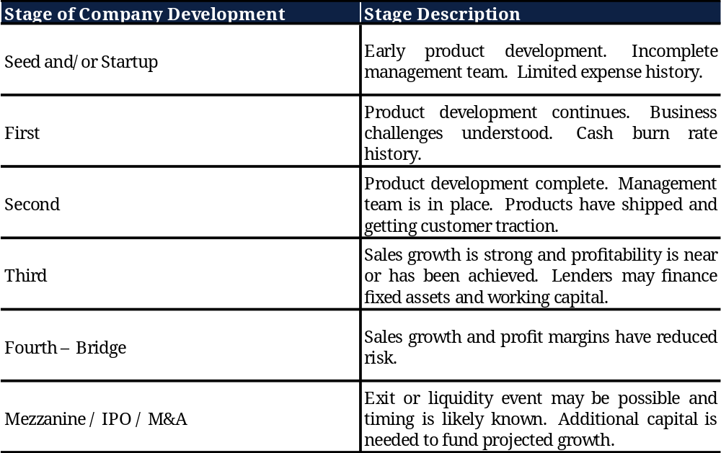

A fair market value buyer of the subject company would require a rate of return consistent with rates of return demanded by venture capital firms, the source of funding for companies like the one considered in this appraisal. The following table summarizes expected annual returns for venture investment in companies in various stages of development. Each column represents a different study, as cited below.

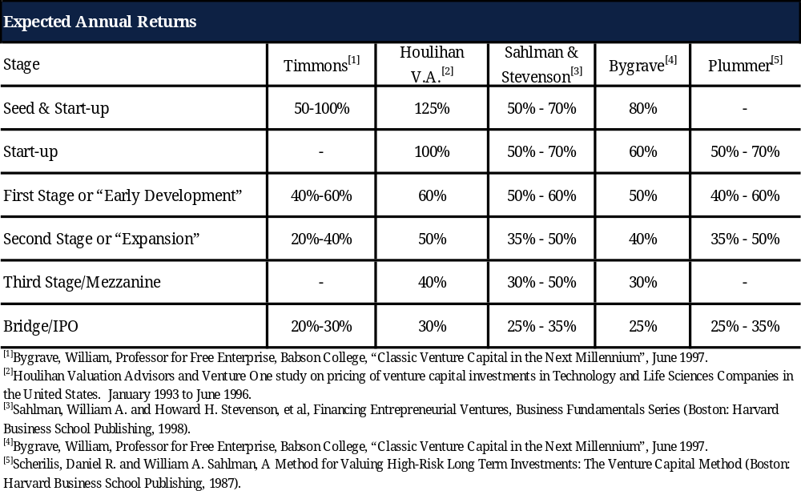
xyz Corp is still in an emerging growth phase of its development with rapid changes in operating model and financial flows. There are additional risks often associated with emerging growth companies, as contrasted with existing operating companies. We therefore considered these factors in developing the appropriate discount rate for the Company to account for these additional risks. The Company is subject to a high possibility of failure given its early stage of development and the highly competitive marketplace in which it operates. The Company may survive but not flourish, resulting in a failure to achieve a level of revenues and profitability required to create a liquidity event for its shareholders.

Causes of failure can be related to macroeconomic issues, such as recession interest rates, unemployment, consumer sentiment and “shocks”, such as wars or terrorist activities. There are also industry-specific, financial, and operational causes of distress. Industry-specific causes can result from overcapacity, global shifts, import and export limitations, restrictions, regulations, technology changes, and obsolescence. Financial causes would include over-extension, insufficient capitalization, and inadequate cash flow for debt service, capital expenditures, or working capital. Operational causes include such events as the loss of a major customer, over-expansion, or failed growth initiatives.
    - Specific Risk Considerations
The Company has above-average risk with respect to the presence of larger, established competitors, and risks associated with failed growth and profitability initiatives. These are factors that must be considered by the appraiser.

xyz Corp’s current phase of operations can best be categorized under the first (“Early Development”) or second (“Expansion”) stage (PICK ONE, DELETE THE OTHER) of business development, as defined above, on a look-forward basis. Therefore, the required rate of return should be somewhere within the 20 to 50 percent range for companies in this stage of their development (see chart above). Given the overall Company and industry operating context, and based on the research and analysis presented above, we believe that a discount rate of XX percent is appropriate for xyz Corp.

THE FOLLOWING SECTION IS FOR WACCS DERIVED (NOT SELECTED)

An investment in a company or asset is subject to certain inherent risks, including market, business, and financial risks. The company's discount rate is positively correlated with its respective amount of investment risk. In contrast, the value of projected cash flows is negatively correlated with the discount rate, reflecting that risk-adverse investors require a higher rate of return for increasing levels of risk. The general formula for calculating the post-tax WACC is:
WACC = [K_{e} * W_{e}] + [W_{d} * K_{d} * (1-t)]
where
K_{e} = Rate of return on equity capital
W_{e} = Equity capital as a percentage of the Total Invested Capital
W_{d} = Debt capital as a percentage of the: (i) sum of the debt, (ii) preferred equity, and (iii) common equity capital (“Total Invested Capital”)
K_{d} = After-tax rate of return on debt capital
t = Tax rate

The K_{e} has been calculated using the Capital Asset Pricing Model (“CAPM”), which has been empirically tested and is widely accepted for the purpose of estimating a company’s required return on capital. In applying the CAPM, the rate of return on capital is estimated as the current risk-free rate of return on government bonds, plus a market risk premium expected over the risk-free rate of return, multiplied by the “beta” for the subject company. Beta is defined as a risk measure that reflects the sensitivity of a company’s stock (or capital) price to the movements of the stock market as a whole. The CAPM is calculated using the formula:

K_{e} = R_{f} + β*ERP + SRP + CSRP
where
R_{f} = Risk-free rate of return
β = Beta or systematic risk for this type of equity investment (re-levered)
ERP = Equity risk premium (the expected return on a broad portfolio of stocks in the market (R_{m}) less the risk-free rate of return (R_{f}))
SRP = Size risk premium
CSRP = Company specific risk premium

The risk-free rate of return (R_{f}) is considered to be the yield to maturity of long-term (20-year) government bonds, which as of the Valuation Date was approximately X.X percent.

Beta (β) is a statistical measure that evaluates the risk of a particular security relative to the systematic risk of a market portfolio of stocks. The beta of a stock is computed by regressing the returns from that stock in excess of the risk-free rate with the returns for a market portfolio of stocks in excess of the risk-free rate. In our analysis, the Company’s beta was estimated at X.X based on the unlevered historical betas of the Guideline Companies, adjusted to a prospective market beta, and re-levered to reflect the capital structure of a hypothetical buyer.
The equity risk premium (“ERP”) is the return on the market in excess of the risk-free rate (Rf). The equity risk premium is based on the average premium over the risk-free rate that investors in common stocks have earned since 1926. As of the Valuation Date, Kroll reported the current risk premium at X.X percent.

The size risk premium (“SRP”) represents an additional premium that is not captured in the capital asset pricing model. Kroll has investigated the relationship between company size and average annual returns from 1926. One of the findings of the Kroll study is that smaller companies have higher returns, indicating higher risk levels, than larger companies. Kroll provides a breakdown of all publicly traded companies into ten deciles as measured by market capitalization and determines the size premium for each company. The tenth decile represents the smallest companies, with a market capitalization between $X.X million and $X.X million and corresponds to a size premium of X.X percent. Based on the Company’s current stage of operations and its level of revenues both historically and projected, we believe this is an appropriate estimation of the size premium for xyz Corp.

The company-specific risk premium (“CSRP”) represents the perceived risk associated with the subject company. Although the determination of risk premiums is based on qualitative judgment, company-specific risk, also called “unsystematic risk,” is comprised of factors that cannot be accounted for in the WACC by the beta and/or the equity risk premium. These factors include:
- Revenue growth.
- Reduced marketability (for privately held businesses).
- Financial risk.
- Operational risk.
- Profitability.
- Industry risk.
- Economic risk.
- Customer concentration.

While the Company is an established, profitable business which has shown consistent growth throughout its 25 years of operations, the wholesale market is extremely consolidated and dominated by large, multi-billion dollar national and international giants – REWRITE TO MATCH SUBJECT COMPANY’S RISK. We believe an additional risk premium of X.X percent is an adequate representation of the additional, unsystematic risk faced by the Company.

The computation of the Company’s cost of equity using the CAPM for a hypothetical buyer within the industry is summarized as follows:

K_{e} = 2.3% + [1.1 x 5.9%] + 5.6% + 2.5% = 17.0%

The rate of return on debt capital (K_{d}) is the current rate an investor would pay for long-term debt capital to finance the business. In determining this rate, we examined the return on debt of the guideline companies. Based on these companies, the long-term cost of debt was estimated to be X.X percent.

The proportion of debt capital to total capital (W_{d}) was based primarily upon the industry’s capital structure as determined through the guideline companies. We relied on a structure of X.X percent equity and X.X percent debt, which implies that companies in the industry are far more reliant on their own funds rather than external borrowings (CHANGE THIS LAST PART IF WEIGHT OF DEBT IS HIGHER).

The marginal tax rate (t) reflects the interest tax shield on debt. The estimated tax rate applied to the Company was 26 percent based on the expected tax rate of a hypothetical ‘C’ corporation.

The estimated WACC for xyz Corp is thus computed as follows:

WACC = [16.9% x 69.7%] + [4.2% x 30.3% x (1 – 26.0%)] = 13.0% (Rounded)

Based on the analysis as detailed above, a discount rate of X percent was applied to the Company’s expected debt-free net cash flows. This rate reflects our assessment of the risk associated with the successful achievement of the forecasted cash flows in comparison to the risks related to the return on investments in comparable publicly traded companies. Please refer to the appendices for further details on the computation of the WACC.
    - DCF Analysis
As shown in the table below, the forecasted net cash flows were discounted to present value using the discount rate selected/derived for the Company.

FOLLOWING SECTION FOR EXIT MULTIPLE METHOD

For the remaining cash flows, we calculated the terminal value using observed metrics developed from a set of comparable public companies and discounting this value to its present value. As the Company is currently in an early stage of its development, as opposed to achieving stable revenues going forward, we felt this approach best captures how a hypothetical buyer would consider the value of the Company.

To determine the terminal value, we examined the Company’s projected 2024 revenues and applied a Business Enterprise Value (“BEV”)-to-Last Twelve Months (“LTM”) Revenue multiple derived from the comparable companies. The selected comparables and their respective multiples can be found in the appendices.

FOLLOWING SECTION FOR EXIT MULTIPLE ADJUSTMENT (SIZE)

In reviewing the guideline companies, we noted significant differences between the guideline companies as compared to xyz Corp. These differences ultimately affect the financial and operational risk differential between xyz Corp and the guideline public companies. Often these adjustments can be substantial due to such risk factors as size, depth of management, systems and controls, product, supply and/or customer diversification and other risk factors which are generally more prevalent in privately held companies, as opposed to publicly traded company. Most of these additional risk factors relate to size. Larger companies tend to have lower risk profiles than smaller companies as a result of greater product, customer and geographic diversification, as well as greater management depth and experience. They also have the capacity to develop specialized management skills, afford stronger systems and control, and have the ability to diversify operations that smaller companies do not have.

In light of these differences, we made a 20 percent downward adjustment to the selected ratio.

FOLLOWING SECTION FOR EXIT MULTIPLE ADJUSTMENT (GRABOWSKI)

We performed a financial analysis of the selected comparables to compare xyz Corp’s financial results with that of the public counterparts to identify the similarities and dissimilarities as between the subject and the guideline companies in order to understand their comparability. We then considered adjustments to the market multiples to account for the differences between the publicly traded guideline companies and xyz Corp. These differences ultimately affect the financial and operational risk differential between xyz Corp and the guideline public companies.

Often these adjustments can be substantial due to such risk factors as size, depth of management, systems and controls, product, supply and/or customer diversification, and other risk factors which are generally more prevalent in privately held companies as opposed to publicly traded companies. Most of these additional risk factors relate to size; larger companies have the capacity to develop specialized management skills, afford stronger systems and control, and diversify operations that smaller companies do not have. We therefore adjusted the guideline companies’ multiples for the difference in size.

To make these adjustments, we considered market studies that have documented the evidence indicating that varying market returns are directly and strongly correlated to the size of a company. These studies identify equity premiums demanded by the market in terms of equity returns (or equity risk premia - ERPs) over time. Hence, the difference in the ERP as between the selected comparables and the subject company is the ERP related to size, and the percentage difference can be used to adjust the multiple for the market-priced risks associated with size. The formula to do so is as follows:

[(1 / Multiple) X (1 + ((GPC [Smoothed ERP] – Subject [Smoothed ERP])/ Subject ERP))] / 1

To compute the size adjustment, we first took each of the multiples derived in the table above and converted them to an implied capitalization rate (1 / multiple = implied capitalization rate). We then calculated the implied ERP by subtracting the risk-free rate component of X.X percent.

After deriving the implied ERP for each company, we compared each company’s smoothed ERP for to xyz Corp’s smoothed ERP. The data used to smooth the ERP was provided by Kroll.

Smoothed Equity Risk Premium = 17.796 percent - 2.442 percent*Log (LTM Revenues)

The required size adjustment was calculated by dividing xyz Corp’s Smoothed ERP each guideline company’s smoothed ERP. We then calculated the new adjusted size premium by multiplying the implied ERP by [1 + size adjustment]. From this new adjusted size premium, we calculated the adjusted capitalization rate by adding the risk-free rate to the adjusted size premium. Finally, the new size adjusted multiples were calculated using the following equation:

Size Adjusted Multiple = (1/adjusted capitalization rate)

For further details regarding this analysis, please refer to the appendices.

PLACE EXIT MULTIPLE CALCULATION TABLE HERE (CENTERED)

The terminal value is then discounted to the Valuation Date using the required rate of return.

FOLLOWING SECTION FOR GORDON GROWTH MODEL

In order to determine the value of the expected cash flows of the Company after the Discrete Projection Period, a constant growth model known as the Gordon Growth Model was utilized. The Gordon Growth Model is a mathematical simplification of a cash flow stream that is expected to grow at a constant rate (g) into perpetuity and discounted at an appropriate rate of return (r). Combining the two factors (r – g) results in a capitalization rate that can be applied to the Company’s terminal year’s net cash flow. By the terminal year of the forecast, the Company’s cash flow and capital structure are anticipated to be at a stabilized level. Taking into consideration the Company’s growth prospects and long-term industry deterioration, as well as the overall expected growth rate of the economy, we estimate the growth rate into perpetuity at X percent.

Capitalizing the terminal year’s net cash flow (excluding the effect of NOLs) results in an indicated terminal value which is then discounted to the Valuation Date using the required rate of return.

The present value of the interim cash flows is then added to the discounted terminal value to derive xyz Corp’s enterprise value. In addition, we also considered the present value of the Company’s outstanding NOL.

The NOL was calculated based on the updated guidelines as dictated by the Tax Cuts and Jobs Act of 2017 (“TCJA”) and The Coronavirus Aid, Relief, and Economic Security (“CARES”) Act of 2022. Any loss incurred before December 31, 2017 was offset against taxable income with no limit. The annual limitation on the utilization of corporate NOL carryovers is 80 percent of earnings before interest and taxes (“EBIT”) for FY 2019 onwards. We estimated the present value of the expected tax savings beyond the Discrete Projection Period as shown in the appendices, which was added to the value concluded by the DCF analysis to arrive at the Company’s Total Enterprise Value (“TEV”).

PLACE DCF MODEL HERE (CENTERED)

    - Equity Value Indication
As discussed earlier, the value indication derived from the DCF analysis is the value of both interest-bearing debt and equity, or total invested capital. Hence, we subtracted debt from the value indication to arrive at an equity value indication.

The Income Approach relies on operating income as a measure of earnings to calculate free cash flow. As such, the method does not value any assets with earnings that do not contribute to operating income, such as cash and marketable securities. In addition, as stated earlier in this report, working capital needs for the Company were projected on a cash-free basis and the resulting investments in working capital, projected in the DCF analysis, are also on a cash-free basis. Therefore, the value of cash and marketable securities must be added to the enterprise value to arrive at an equity value indication.

Income approach
  - Market Approach Analysis
    - Application of the Guideline Public Company Method
A fundamental method for estimating the value of the stock of a closely held business is an analysis of prices paid by investors in the private, or, most often due to the availability of information, the public markets for the stock of other companies in the same or similar lines of business. One methodology within the market approach is the guideline company method, which uses comparable companies to the subject business whose stock is publicly traded. We found stock activity of publicly traded companies that were deemed broadly comparable to xyz Corp and applied this methodology.

The theory behind the guideline public company method to the market approach of valuation is that prices of publicly traded stocks in the same or similar industry provide objective evidence as to the values at which investors are willing to buy and sell interests in companies in that industry. In applying the guideline public company method, we compute a value multiple for each guideline public company. The appropriate multiple is then determined and adjusted for the unique aspects of the company being valued. This multiple is then applied to the company being valued to arrive at an estimate of value for the appropriate ownership interest.

Guideline Public Company Search Strategy
In selecting potentially comparable companies, we relied on a benchmark search using Standard & Poor’s Capital IQ Database (“Capital IQ”) for companies that are peer companies to xyz Corp. The following steps were taken:
- Search criteria inputted into Capital IQ, including identification of the appropriate industry classification codes.
- Performance of quantitative screens.
- Performance of qualitative screens.
- Assessment of potential adjustments to the selected comparables.

Public companies were selected based on the following criteria, which were fine-tuned based on the availability of data. The following describes the strategy:
- Industry Classification (Primary): Automobiles and Components; Motor Vehicles and Parts Distribution; Automotive Retail; OR
- SIC Code (Primary): 5010 – Motor Vehicles and Motor Vehicle Parts and Supplies; 5012 – Automobiles and Other Motor Vehicles; 5012 – Motor Vehicle Supplies and New Parts; 5014 – Tires and Tubes; 5015 – Motor Vehicle Parts, Used.
- Keywords (Business Description): List any keywords used in the search in this format – “software”, “SaaS”, “billing”
- Geographic Location (Primary): The United States and Canada
- Company Type: Public Company
- ADD ANY RELEVANT CRITERIA USED (NO NEED TO ADD SIMPLE QUANTITATIVE CRITERIA SUCH AS REVENUES ABOVE 0, TEV ABOVE 0, ETC.), BUT NOTE ANY LIMITS SET ON DATA (SUCH AS LTM REVENUES: LESS THAN $500 MILLION).

In order to achieve the most comparable set, qualitative screens were applied, which were fine-tuned based on the information available. These screens included a review of the companies’ business descriptions provided by Capital IQ and the companies’ websites.

Derivation of Valuation Multiple
For our analysis, we computed the ratios for the guideline companies’ estimated calendar year (“CY”) 2022 revenues and EBITDA to their Business Enterprise Value (“BEV”) as of the Valuation Date. (REMOVE FOOTNOTE IF BEV ALREADY DEFINED IN EXIT MULTIPLE SECTION) The selected comparables and their respective multiples can be found in the appendices.

IF DISCUSSING SIZE ADJUSTMENT FOR FIRST TIME:

In reviewing the transactions, we noted significant differences between the target companies as compared to xyz Corp. These differences ultimately affect the financial and operational risk differential between xyz Corp and the guideline public companies. Often these adjustments can be substantial due to such risk factors as size, depth of management, systems and controls, product, supply and/or customer diversification and other risk factors which are generally more prevalent in privately held companies, as opposed to publicly traded company. Most of these additional risk factors relate to size. Larger companies tend to have lower risk profiles than smaller companies as a result of greater product, customer and geographic diversification, as well as greater management depth and experience. They also have the capacity to develop specialized management skills, afford stronger systems and control, and can diversify operations that smaller companies do not have.

In light of these differences, we made a 20 percent downward adjustment to the selected ratio.

IF SIZE ADJUSTMENT ALREADY USED:

The 20 percent downward adjustment as discussed above was made to these multiples as well.

Adjustment of Valuation Multiple (GRABOWSKI)
IF NEEDED, COPY/PASTE ADJUSTMENT SECTION FROM EXIT MULTIPLE. OTHERWISE:

We then considered adjustments to the market multiples to account for the differences between the publicly traded guideline companies and xyz Corp. These differences ultimately affect the financial and operational risk differential between xyz Corp and the guideline public companies.

For further details regarding this analysis, please refer to the appendices.

Equity Value Indication
After applying the multiples derived through our analyses, we subtract the interest-bearing debt and add back cash to derive the Company’s equity value. IF WEIGHTING IS NOT EQUAL BETWEEN ANALYSES, YOU MUST PROVIDE REASONING.

Market approach
    - Application of the Guideline Transaction Method
Another methodology under the market approach to valuation is the merger and acquisition method, also known as the guideline transaction method, which uses a statistical analysis of all relevant data relating to the sale and acquisition of businesses similar to the subject company, comparing market values of similar company transactions. In this particular instance, we were able to find several transactions for businesses in the same industry.

When valuing the stock of closely held companies, the values of merger and acquisition transactions can be considered as relevant factor that can provide guidance on the value of the subject company; these are called guideline transactions. To be truly similar to the subject company, the target company in a guideline transaction should be engaged in the same or a similar line of business, and its size, capital structure, and trend of sales and earnings should be similar.

Guideline Transaction Search Strategy
We searched for information on mergers and acquisitions of companies comparable to xyz Corp using Capital IQ. The following describes the strategy:
- Industry Classification (Primary): Automobiles and Components; Motor Vehicles and Parts Distribution; Automotive Retail; OR
- SIC Code (Primary): 5010 – Motor Vehicles and Motor Vehicle Parts and Supplies; 5012 – Automobiles and Other Motor Vehicles; 5012 – Motor Vehicle Supplies and New Parts; 5014 – Tires and Tubes; 5015 – Motor Vehicle Parts, Used.
- Keywords (Business Description): List any keywords used in the search in this format – “software”, “SaaS”, “billing”
- Geographic Location (Primary): The United States and Canada
- Transaction Type: Mergers/Acquisitions
- All Transactions Closed Date: 1/1/2018 – 12/31/2019
- ADD ANY RELEVANT CRITERIA USED (NO NEED TO ADD QUANTITATIVE CRITERIA SUCH AS REVENUES ABOVE 0, TEV ABOVE 0, ETC.).

For our analysis, we computed the ratios for the target companies’ LTM revenues and EBITDA to the enterprise value implied by the transaction. The selected transactions and their respective multiples are provided in the appendices. We note that these multiples were not adjusted as our search only included transactions involving companies similar in size to xyz Corp.

IF DISCUSSING SIZE ADJUSTMENT FOR FIRST TIME:

In reviewing the transactions, we noted significant differences between the target companies as compared to xyz Corp. These differences ultimately affect the financial and operational risk differential between xyz Corp and the guideline public companies. Often these adjustments can be substantial due to such risk factors as size, depth of management, systems and controls, product, supply and/or customer diversification and other risk factors which are generally more prevalent in privately held companies, as opposed to publicly traded company. Most of these additional risk factors relate to size. Larger companies tend to have lower risk profiles than smaller companies as a result of greater product, customer and geographic diversification, as well as greater management depth and experience. They also have the capacity to develop specialized management skills, afford stronger systems and control, and have the ability to diversify operations that smaller companies do not have.

In light of these differences, we made a 20 percent downward adjustment to the selected ratio.

IF SIZE ADJUSTMENT ALREADY USED:

The 20 percent downward adjustment as discussed above was made to these multiples as well.

Adjustment of Valuation Multiple
IF NEEDED, COPY/PASTE ADJUSTMENT SECTION FROM EXIT MULTIPLE. OTHERWISE:

We then considered adjustments to the transaction multiples to account for the differences between the target companies and xyz Corp. These differences ultimately affect the financial and operational risk differential between xyz Corp and the acquired companies.

For further details regarding this analysis, please refer to the appendices.

Equity Value Indication
After applying the multiples derived through our analyses, we subtract the interest-bearing debt and add back cash to derive the Company’s equity value.

Market approach
    - Application of the Guideline Venture Funding Method
The Guideline Venture Funding, or Backsolve, Method involves estimating the value of the firm by taking the price of the last venture investment or share issuance and calculating the equity value that would be required for that preferred series to receive its original investment amount given certain assumptions about the exit event and the company’s capital structure.

During xyz Corp’s latest financing round, Series X Shares were issued at a price per share of $X.XX. By using the OPM, we can back-solve for the Company’s equity value which results in this price for said shares. In this variation of the OPM, rather than using an equity value and deriving a share value, a share price is used to solve for the Company’s value at which the most recently issued shares effectively “break even.”

The OPM values a company’s shares by creating a series of call options with exercise prices based on the liquidation preferences and conversion behavior of the different classes of equity. The OPM considers the various terms of the stockholder agreements that would affect the distributions to each class of equity upon a liquidity event, including the level of seniority among the securities, dividend policy, conversion ratios, and cash allocations. In addition, the method implicitly considers the effect of the liquidation preference as of the future liquidation date, not as of the valuation date.

Once the fair value of the enterprise is established, the OPM values the common shares by creating a series of call options with exercise prices based on the liquidation preferences and conversion behavior of the different classes of equity. Before the common shareholders receive any value, the holders of preferred shares would receive their full liquidation preference; that is, the common stock only has value if the total equity value at the time of a liquidation event exceeds the value of the preferred shares’ full liquidation preference.

Our analysis assumes that as the value of the Company increases, each equity holder benefits from certain value components. We determined the ranges of equity values at which the various Company stakeholders receive value. The maximum values of these ranges, or “transition points,” are based on the full liquidation preference amounts, the point at which option and/or warrant holders choose to exercise, or the points at which the preferred shareholders would be indifferent between converting their shares into common and retaining their preferred shares.

We used the Black-Scholes option pricing model to isolate the value allocated to each “range” (discussed above), calculated as the difference between the option values at each breakpoint. Based on the Company’s capital structure and the rights of each shareholder class, we calculated the percentage of each range attributable to each share class. For each range, the value allocable to each share class was then calculated by multiplying the value of each range by each security’s respective percentage in which it shares in the range. The value of attributed to each class of equity in each range was summed to determine their aggregate value.

The transition points computed for the Company and the participating classes of shares are summarized in the table below.

Note
— | Not applied in Draft D1 — complete from the workfile at D2.

The X share price scenarios within the OPM are shown below along with the calculation of the call prices for each scenario.

Note
— | Not applied in Draft D1 — complete from the workfile at D2.

As noted previously, each transition band (“TB”) identified above represents a separate call option with a claim on the equity value of the Company. The equity value allocated to each transition band is presented in the final row of the calculation above. Based on their respective rights and preferences, each of the classes in the equity structure will participate in the equity value attributable to each transition band (or call option) on a different basis. The participation in the value of each transition band for the various classes is set out below.

Note
— | Not applied in Draft D1 — complete from the workfile at D2.

The final allocation of value among the various classes of shareholders within OPM is shown in the following table.

Note
— | Not applied in Draft D1 — complete from the workfile at D2.

IF 100% ROPM, PROCEED DIRECTLY TO DLOM SECTION
  - Cost Approach Analysis
As of the Valuation Date, the only material asset held by the Company is the intellectual property (“IP”) related to its PRODUCT DESCRIPTION. In developing our estimate of the replacement value, we discussed with Management at length all of the relevant costs, both tangible and intangible, that were incurred to date. In the event that there were certain costs that were not reflected in the financial statements provided, such as labor hours deployed by the founder(s) or costs incurred to develop the products, we have included them in our analysis. We have also made adjustments to include any other costs that we thought would be necessary to replicate the IP, whether or not implicitly stated or incurred by the Company. These include reasonable allowances that would be incurred by a hypothetical third party seeking to build these assets from scratch.
    - Underlying Assumptions
In the course of the Replacement Cost Analysis, we relied on information, data, and estimations collected through our discussions with Management.

- Sweat Equity
Sweat equity is the non-monetary investment that owners or employees contribute to a business venture. This term is often used to refer to the effort and toil a company’s owners and employees contribute to a project or enterprise—and the value it creates. In cash-strapped startups, owners and employees typically accept salaries that are below their market values in return for a stake in the company, which they hope to profit from when the business is eventually sold.

PROVIDE WRITE-UP ON THE DATA COLLECTED, ASSUMPTIONS MADE, AND CALCULATIONS USED.

Based on … we have estimated Sweat Equity at $X.

- Labor Costs
The Company has employed….. The estimated labor costs pertaining to these employees to date is $X. IF THE COMPANY HAS SEGMENTED COSTS PERTAINING TO CONTRACTORS, CREATE A SEPARATE SECTION FOR THAT.

- Development Costs
Since inception, the Company has spent approximately $X on …., which we have considered to be the development costs.

- Operating Costs
The operating costs included in our analysis reflect ….. Based on…, we have estimated operating costs to be $X.

- Computer/Desks/Office Space Costs
According to Management, the Company has spent $X since inception on….

- Payroll Taxes, Healthcare and Other Employee Benefits
Management has indicated that the Company has, to date, incurred costs totaling $X on payroll taxes, healthcare, retirement, and other benefits.

- Professional Recruitment/Professional Fees
Management has indicated that …. Based on …, we have estimated professional recruitment/professional fees from inception through the Valuation Date to be $X.
    - Summary
The estimated replacement cost for xyz Corp, considering both the tangible and intangible asset costs that have been incurred to date, is summarized in the table below. In addition, we have added a return on the costs incurred known as the “developer’s profit.” The developer’s profit represents a fair profit margin that an independent company would charge to the client to develop a product similar to the one currently in development by the Company. Based on the profit margins observed in the industry as well as data provided by New York University professor Aswath Damodaran, we have estimated a developer’s profit margin of XX percent.

Asset approach
  - Selection of Methodology and Weighting
Following our analyses under the income and market approaches, it was concluded that both approaches provided a reasonable estimate of value for the Company as of the Valuation Date. After examination of the analyses applied, we attributed 50 percent weight to the Income Approach and 50 percent weight to the Market Approach. There is no basis on which to deem one approach superior to the other, and both are reasonable and globally recognized and utilized valuation approaches. IF WEIGHTING IS NOT EQUAL BETWEEN APPROACHES, YOU MUST PROVIDE REASONING.

Determination method | Indicative equity value | Weight
Income approach (discounted cash flow) | Not applied | 0.0%
Market approach (guideline public companies) | Not applied | 0.0%
Supplied / invested capital | Not applied | 0.0%
Weighted equity value | — | —
  - Allocation of Equity
IF ROPM WAS USED, DELETE EVERYTHING IN GREEN

The OPM values a company’s shares by creating a series of call options with exercise prices based on the liquidation preferences and conversion behavior of the different classes of equity. The OPM considers the various terms of the stockholder agreements that would affect the distributions to each class of equity upon a liquidity event, including the level of seniority among the securities, dividend policy, conversion ratios, and cash allocations. In addition, the method implicitly considers the effect of the liquidation preference as of the future liquidation date, not as of the valuation date.

Once the fair value of the enterprise is established, the OPM values the common shares by creating a series of call options with exercise prices based on the liquidation preferences and conversion behavior of the different classes of equity. Before the common shareholders receive any value, the holders of preferred shares would receive their full liquidation preference; that is, the common stock only has value if the total equity value at the time of a liquidation event exceeds the value of the preferred shares’ full liquidation preference.

Our analysis assumes that as the value of the Company increases, each equity holder benefits from certain value components. We determined the ranges of equity values at which the various Company stakeholders receive value. The maximum values of these ranges, or “transition points,” are based on the full liquidation preference amounts, the point at which option and/or warrant holders choose to exercise, or the points at which the preferred shareholders would be indifferent between converting their shares into common and retaining their preferred shares.

We used the Black-Scholes option pricing model to isolate the value allocated to each “range” (discussed above), calculated as the difference between the option values at each breakpoint. Based on the Company’s capital structure and the rights of each shareholder class, we calculated the percentage of each range attributable to each share class. For each range, the value allocable to each share class was then calculated by multiplying the value of each range by each security’s respective percentage in which it shares in the range. The value of attributed to each class of equity in each range was summed to determine their aggregate value.

IF ROPM WAS NOT USED, DELETE EVERYTHING IN BLUE

The allocation of the Company’s equity was determined using the Option Pricing Method. As previously discussed, the first steps in applying the OPM are establishing the fair value of the subject company and determining the transition points. For this analysis, we are relying on the equity value of concluded for the Company. The transition points have also remained identical, aside from the point corresponding to the exercise of the still-unissued options, which is now based on the result of this analysis.

The transition points computed for the Company and the participating classes of shares are summarized in the table below.

Note
— | Not applied in Draft D1 — complete from the workfile at D2.

The X share price scenarios within the OPM are shown below along with the calculation of the call prices for each scenario.

Note
— | Not applied in Draft D1 — complete from the workfile at D2.

As noted previously, each transition band (“TB”) identified above represents a separate call option with a claim on the equity value of the Company. The equity value allocated to each transition band is presented in the final row of the calculation above. Based on their respective rights and preferences, each of the classes in the equity structure will participate in the equity value attributable to each transition band (or call option) on a different basis. The participation in the value of each transition band for the various classes is set out below.

Note
— | Not applied in Draft D1 — complete from the workfile at D2.

The final allocation of value among the various classes of shareholders within OPM is shown in the following table.

Note
— | Not applied in Draft D1 — complete from the workfile at D2.

USE FOLLOWING SECTION FOR SIMPLE CAPITAL STRUCTURE

Given the Indicative Equity Value noted above, we then utilized the Black Scholes Option Pricing Model to calculate the value of the Company’s outstanding options. In addition to the X.X million options already issued and outstanding, the Company is expecting to grant options with an exercise price as determined from this analysis, which we have included in our calculation.

Item | Value
Option shares | 0
Average strike | $0.00
Allocated option value (OPM) | —

Using the Black Scholes model, we determined the value of the Company’s options. As shown in the capitalization table, the Company has X million shares of common stock outstanding (not including the options) we calculated the per-share value of the common stock as shown below.

Item | Value
Option shares | 0
Average strike | $0.00
Allocated option value (OPM) | —
  - Discount for Lack of Marketability
In the economic valuation literature, there is significant discussion regarding whether stocks that are not marketable should have a discounted price as contrasted with the same completely marketable stock. A liquidity discount, also often referred to as a “marketability discount”, “discount for lack of marketability (DLOM)”, or “illiquidity discount”, is the difference in price which an investor will pay for a liquid asset compared to a comparable illiquid asset. The notion of liquidity is crucial for practitioners and investors who value assets that do not have readily available market quotations.

Because the common shares being valued represent interests in a closely held entity, adjustments must be made to the preliminary fair market value estimate arrived at on a freely traded basis. The uncertain economic environment further reduces the appetite of investors for illiquid, hard-to-value securities such as the Company’s common shares. Based on our research and analysis, and in consideration of the results of the Protected Put methodology in conjunction with the Black Scholes formula, we ultimately applied a DLOM of XX percent. Further details regarding this analysis can be found in the appendices.

IF WE SELECT A DLOM ABOVE THE RANGE OF THE MODELS:

In considering the appropriate discount to apply, we considered the results of quantitative models (see appendices) as well as qualitative factors affecting the common and the subject stock. One factor we considered is that, under the current highly volatile, uncertain, and recessionary economic conditions, equity markets and the overall appetite for investors in private illiquid equity shares has been negatively affected. The common shares represent the riskiest equity securities of the Company, and the least marketable. Consequently, in consideration of all these factors, and based on the current market conditions as outlined above, the discount for lack of marketability for xyz Corp’s common shares is reasonably estimated at XX percent.
  - Discount for Lack of Voting Rights
SAMPLE DISCUSSION ON LACK OF VOTING RIGHTS – REVISE AS NECESSARY

As the Class B common shares do not have voting rights as compared to Class A common shares, they are inherently less marketable. As such, we applied an additional 5 percent discount to account for the Class B common shares’ lack of voting rights (see appendices).
  - Consideration of Recent Transactions
IF THERE WERE ANY SECONDARY AND/OR INSIDER TRANSACTIONS, PROVIDE A SUMMARY OF THESE TRANSACTIONS – INCLUDING PARTIES INVOLVED, DATES, QUANTITIES, PRICES, TOTAL VALUES, ETC.
    - Reconciliation of Value
In all valuation approaches used to estimate value we have endeavored to account for the future growth, risk and cash flow of the Company. Therefore, all valuation approaches used in this report potentially represent reasonable estimates of value as of the Valuation Date.

The recent insider transactions are conceptually based on the principle that transactions in the security under consideration are the best indications of fair market value. Third-party transactions in the equity of a private enterprise generally represent the best estimate of fair market value if they are recent and completed at arm's length. This theory is related to the understanding that equity transactions in the public market fairly demonstrate the value of public companies. Usually, the standard of whether a transaction is recent enough to contribute meaning to the analysis depends on what events have happened in the interim that might change the value of the subject.

This approach may represent arguably the conceptually strongest methodology to estimate fair market value. As has been noted by the AICPA, “a significant limitation of the market approach in general is that ‘true’ comparables are unlikely to exist, particularly in valuing privately held enterprises [or their underlying securities]. Another general limitation arises if the enterprise being valued has no earnings, as forecasts of financial statements may then be highly speculative.” The AICPA goes on to note that, in selecting this approach, while the basis of application is a transaction or transactions in equity securities of the enterprise, the valuation specialist should consider whether the transactions involve any stated or unstated rights or privileges whose effects may ordinarily be factored out of any appropriate determination of value. We believe the recent insider transactions in question might establish a potentially meaningful valuation data point for purposes of determining the value of equity.

In assessing the relevance of a recent transaction in a company’s securities, the valuator needs to consider the following:
- Is the transaction for an identical security on the measurement date? As noted above, the transactions involved several classes of units identical to those being valued in this report.
- Does the evidence indicate that the transaction is orderly or not orderly? ASC 820 defines an orderly transaction as "a transaction that assumes exposure to the market for a period before the measurement date to allow for marketing activities that are usual and customary for transactions involving such assets or liabilities; it is not a forced transaction (for example, a forced liquidation or distress sale)." As the Company has not been forced into liquidation and is not in distress, we have concluded that this is an orderly transaction.

Based on the answers to these questions, the AICPA guide recommends that these transactions’ price(s) be taken into account. The weighting placed on these transactions will depend on the following factors:
- Timing of the transaction data.
- Sufficient sophisticated bidders.
- Sufficient information to value the investment and make an investment decision.
- Pattern of trades.
- Other biases or costs of holding, hedging, or trading the securities.

In determining the appropriate weight which should be attributed to these transactions, we considered the following:
- LIST FACTS CONSIDERED AND WHY THEY WERE RELEVANT TO OUR CONCLUSION.
    - Conclusion
Based on the factors as outlined above and…CONCLUDE WHY WE ULTIMATELY TO RELY ON OR DISREGARD THESE TRANSACTIONS.
  - Final Value
After performing the valuation analyses as presented herein, we have determined a per-share fair market value of $X.XX for xyz Corp’s common shares.

Equity value (controlling, marketable) | —
Common value per share, pre-DLOM | —
Discount for lack of marketability | 20.0%
Fair market value per common share | —
- Summary and Results
Based on the preceding analysis, the estimated fair market value of xyz Corp’s common shares on a closely held, minority, and non-marketable per-share basis is:

Per common share: [insufficient inputs]

Based upon the representations of Management and the valuation analyses performed and described herein, it is our opinion that the estimated fair market value of xyz Corp’s common stock, on a minority non-marketable basis, as of the Valuation Date, is reasonably estimated in the amount of [insufficient inputs] per share.

During the course of our valuation analyses, we were provided with financial and operational data regarding the Company. Without independent verification, we have relied upon these data as accurately reflecting the results of the operations and financial position of the Company. We have reviewed for reasonableness these data, in light of the industry and economic data discussed in this report and the results of our interviews of Management, and we have no reason to believe the data are unreasonable. However, as valuation consultants, we have not audited these data and express no opinion or other form of assurance regarding their accuracy or fairness of presentation.

We are unrelated to the Company and have no current or expected interest in the Company or its assets. The results of our analyses were in no way influenced by the fee paid for our services. A Statement of Limiting Conditions under which this assignment was performed is included as an attachment, incorporated herein by reference, to this report.

Statement of Limiting Conditions
- This report is limited to issues concerning compliance with IRC §409(A). Additional issues may exist that could affect the federal tax treatment of the interests that are subject to the report, and the report does not consider or provide a conclusion with respect to any additional issues. Our report is not intended or written to be used, and cannot be used, by the Company or any other person or entity, for the purpose of avoiding any penalties that may be imposed on any taxpayer.

- We have no reason to believe, and no facts have come to our attention to cause us to believe, that the information set forth in this Report is not correct.

- In the course of this engagement, Oxford Valuation Partners has been provided with written information, oral information and data in electronic form related to the Company’s financial and operating performance, its capital structure and other matters relevant to the valuation analysis. Oxford Valuation Partners has relied upon the accuracy of the financial statements provided by the Company with no independent verification of its accuracy or completeness.

- The information furnished by others, including Company management, is presumed to be reliable and no responsibility is assumed for its accuracy or completeness. Oxford Valuation Partners issues no warranty or other form of assurance regarding the accuracy of information furnished by others.

- We have not performed an examination or compilation of the Company’s financial forecasts in accordance with standards established by the American Institute of Certified Public Accountants (AICPA). Consequently, we do not express an opinion or any other form of assurance on the reasonableness of the forecast data or their underlying assumptions or if any of the forecasts are presented in conformity with AICPA presentation guidelines.

- Certain financial data used in our analysis has relied upon management’s adjustments to the financial statements, which are assumed to be in accordance with generally acceptable accounting principles. We have not independently verified the accuracy or completeness of the data provided and do not express an opinion or offer any form of assurance regarding its accuracy or completeness.

- Oxford Valuation Partners assumes no hidden or unapparent conditions regarding the subject assets, properties, or business interests. We did not consider the impact of any liens or encumbrances except as specifically stated and did not conduct any physical inspection of any properties or assets of the Company. For the purposes of the valuation analysis, we have assumed that there is full compliance with all federal, state, and local laws and that all required licenses or consents have been or can be obtained from the requisite regulatory authority.

- This Report has been prepared solely for the person or persons to whom it is addressed and solely for the purpose stated; this Report may not be used for any other purpose, and no party other than the Company may rely on it for any purpose whatsoever. Except as set forth in this Report, neither this Report nor any portions hereof may be copied or disseminated through advertising, public relations, news, sales, Securities and Exchange Commission disclosure documents, or any other media without the express written consent of Oxford Valuation Partners. Possession of this report does not carry with it the right of publication.

- In accordance with US Treasury rules, the advice contained herein was not intended or written to be used, and cannot be used, by any person for the purpose of avoiding penalties that may be imposed by the Internal Revenue Code or applicable state or local tax laws.

- The opinions of value contained herein are not intended to represent the value of the subject assets at any time other than the Valuation Date that is stated in this Report. Changes in market conditions that take place after the Valuation Date could result in opinions of value that are materially different from those offered and Oxford Valuation Partners assumes no responsibility for such changes, except as otherwise stated in this Report. We offer no opinion as to whether the Company would actually be sold for the amount offered as its fair market value.

- Our fees for this service are not contingent upon the valuation opinion expressed herein, and neither Oxford Valuation Partners nor any of its staff have a present or intended financial interest in the Company.

- Oxford Valuation Partners is not required to provide additional work or services, to give testimony or be in attendance in court with reference to the assets, properties, or business interest in question, or to update any report, analysis, or conclusion unless arrangements acceptable to Oxford Valuation Partners have been separately agreed with the Company. Oxford Valuation Partners reserves the right to make adjustments to the analysis, opinion, and conclusions presented in this Report as we deem necessary in consideration of additional or more reliable data that may become available.

Certification
The undersigned hereby certifies that the members of our engagement team have no direct or indirect financial interest in the property that is the subject of this assignment, nor do they have any direct or indirect personal interest with respect to the property or parties involved in the assignment. Neither our employment nor our compensation in connection with the report is any way contingent upon the recommendations reached or value estimated, and this report sets forth all of the assumptions and limiting conditions affecting the analysis. This report is intended to have been prepared in accordance with the guidelines recommended by AICPA’s Statement on Standards for Valuations No. 1 and AICPA’s practice aid, Valuation of Privately-Held Company Equity Securities Issued as Compensation (the Practice Aid). It also adheres to the requirements of the Principles of Appraisal Practice and Code of Ethics of the Business Valuation Standards of the American Society of Appraisers, and the Uniform Standards of Professional Appraisal Practice as set forth by the Appraisal Standards Board of the Appraisal Foundation. To the best of our knowledge and belief, all statements of fact contained in this report are true and correct.

__________________________
Sanjay Gandhi
President
Oxford Valuation Partners, Inc.
sgandhi@oxfordvp.com

September 3, 2026

APPENDICES

APPENDIX A: WEIGHTED AVERAGE COST OF CAPITAL

PLACE CAPM/BUM TABLE HERE (CENTERED) – IF BETA/WEIGHTS WERE DERIVED FROM THE COMPARABLE COMPANIES, INSERT SECTION BREAK, CHANGE TO LANDSCAPE ORIENTATION AND PASTE WACC DATA TABLE ON NEXT PAGE.

APPENDIX B: CALCULATION OF NOL

Note
Not applied in Draft D1 — complete from the workfile at D2.

APPENDIX C: GUIDELINE COMPANIES – BUSINESS DESCRIPTIONS
eGain Corporation operates as a software-as-a service provider of customer engagement solutions in the United States, the United Kingdom, India, and internationally. It provides eGain solution, a unified cloud software solution to automate, augment, and orchestrate customer engagement, including digital-first, Omni channel desktop, artificial intelligence (AI) and knowledge, and analytics and machine learning applications, as well as platform APIs and pre-built third-party connectors. The company’s suite includes various applications for digital interaction, knowledge management, and AI-based process guidance. It also provides integrated analytics for contact centers and digital properties to measure, manage, and optimize resources. In addition, the company offers subscription services and customer support services consulting services, including implementation, custom solution development, and systems integration services and education services, such as training programs, as well as online tutorial modules. It serves customers in various industry sectors, including the healthcare, retail, telecommunications, financial services, insurance, outsourced services, technology, utilities, government, manufacturing, and consumer electronics industries. The company was founded in 1997 and is headquartered in Sunnyvale, California.

APPENDIX D: GUIDELINE COMPANIES – FINANCIAL DATA

Note
Not applied in Draft D1 — complete from the workfile at D2.

APPENDIX E: GPC MULTIPLES ADJUSTMENT

Note
Not applied in Draft D1 — complete from the workfile at D2.

APPENDIX F: VOLATILITY
Volatility calculation for Guideline Venture Funding Method

Note
Not applied in Draft D1 — complete from the workfile at D2.

Volatility calculation for OPM (DELETE THIS HEADER IF ROPM WAS NOT USED).

Note
Not applied in Draft D1 — complete from the workfile at D2.

APPENDIX G: GUIDELINE TRANSACTIONS

Note
Not applied in Draft D1 — complete from the workfile at D2.

APPENDIX H: TRANSACTION MULTIPLES ADJUSTMENT

Note
Not applied in Draft D1 — complete from the workfile at D2.

APPENDIX I: DISCOUNT FOR LACK OF CONTROL
A discount for lack of control is a reduction in the control value of the subject to reflect the fact that a non-control owner cannot control the daily activities or policy decisions of an enterprise. Such activities and policy decisions can include the ability to: appoint management determine management compensation and perquisites set policy and change the course of business acquire or liquidate assets select people with whom to do business and award contracts make acquisitions liquidate, dissolve, sell out or recapitalize the company register the company’s stock for a public offering declare and pay dividends change the articles of incorporation or bylaws and/or block any of these actions.

Additionally, except as state statute may otherwise apply, non-control shareholders do not have access to the underlying asset values since they cannot force liquidation. Given the foregoing, the owner of a controlling interest in an enterprise enjoys very valuable rights that an owner who is not in a controlling position cannot participate.

Regarding the discount for lack of control, H. Calvin Coolidge, in the July 1980 Illinois Bar Journal, wrote:

“The holder of a minority interest can at best elect only a minority of the directors and, for corporations charted in states which do not permit cumulative voting, he may not be able to elect even one director. Lacking control of the board of directors, he cannot compel payment of dividends which must be declared equally and which would give him his pro rata share of earnings. Lacking control of the board of directors, he cannot compel his election as an officer or his employment by the corporation, which the holders of the controlling interest can do, often with the resultant no voice in corporate affairs and is at the mercy of the holders of the controlling interest who have no reason to pay anything but a token dividend, if any, and no reason to buy out the minority holder except at a nominal price.

A willing buyer contemplating purchase from a willing seller of a minority interest, being under no compulsion to buy (which would exclude a buyer already owning some shares whose new purchase would cover control), would suffer the same disadvantages of lack of control. The buyer is asked to make an investment with no assurances as to the certainty of current yield or as to when, or the amount at which, he may be able to liquidate his investment. Regardless, therefore, of the value of 100 percent of the corporation, the buyer will not purchase a minority interest except at a discount from its proportionate share of the value of 100 percent of the corporation.”

In theory, the size of the discount is directly related to the level of control in the fundamental business decisions between a controlling interest and a minority interest. It would be a weak and subjective argument to assign a discount rate based solely on a valuer’s judgment of any particular situation, the valuer not being privy to shareholder and/or board discussions as to the relative amount of control between the controlling interest and the minority interest.

Empirical Evidence
Several empirical studies have been undertaken to attempt to isolate control issues from other issues to measure the value of control and, hence, the lesser value of lack of control.

The market evidence available to assist in quantifying control premiums and/or minority discounts generally compares control acquisition prices with pre-acquisition minority interest transaction prices. The theory behind a control premium study is to measure the premium over minority interest transaction prices at which a controlling interest in the same company was transacted. The value of such a study is to minimize other factors affecting price by comparing public market trading prices before an announcement of merger or acquisition to the merger/acquisition price. The percentage of the acquisition price over the prior minority trading price is commonly called the control premium. Conversely, the percentage below the acquisition price at which the minority stock had been trading is commonly called the minority discount.

For the purpose of evaluating the amount of discount appropriate for a lack of control interest in the subject company we reviewed four extensive studies on control premiums/minority discount, both of which are summarized below. The first is found in the Mergerstat Control Premium Studies, published Business Valuation Resources, and the second in Houlihan, Lokey, Howard & Zukin’s Control Premium Study. Finally, we considered discounts to net asset value of closed end mutual funds.

Mergerstat Review describes its database as follows:

“The Mergerstat Review Research Department tracks publicly announced formal transfers of ownership of at least 10 percent of a company’s equity where the purchase price is at least $1 million, and where at least one of the parties is a US entity. These transactions are recorded as they are announced, not as they are completed. Open market stock purchases are not recorded. For sellers in our database with competing bids, only the highest offer is included in our calculations. Canceled transactions are deducted from total announcements for that period. Unless otherwise noted, all merger and acquisition statistics contained in this publication reflect completed or pending transactions as of the end of the applicable period.”

The millions of daily share transactions on the public stock exchanges are minority transactions since each small block of the shares traded lacks control. But each year, a controlling interest in hundreds of these public companies is purchased. In most cases, the price paid to acquire control represents a premium over the market price at which the stock had traded as a minority interest. A control premium of 33% translates to a 25% discount for lack of control. A 15% control premium translates to a 13% discount for lack of control. Therefore, minority discounts can be calculated by using the following formula:

1 – ( 1 / ( 1 + control premium ) )

The table on the following page presents the average and median premiums offered over market price for transactions collected from this research (as published in Mergerstat Review). The right-most column represents the calculated lack of control discount value.

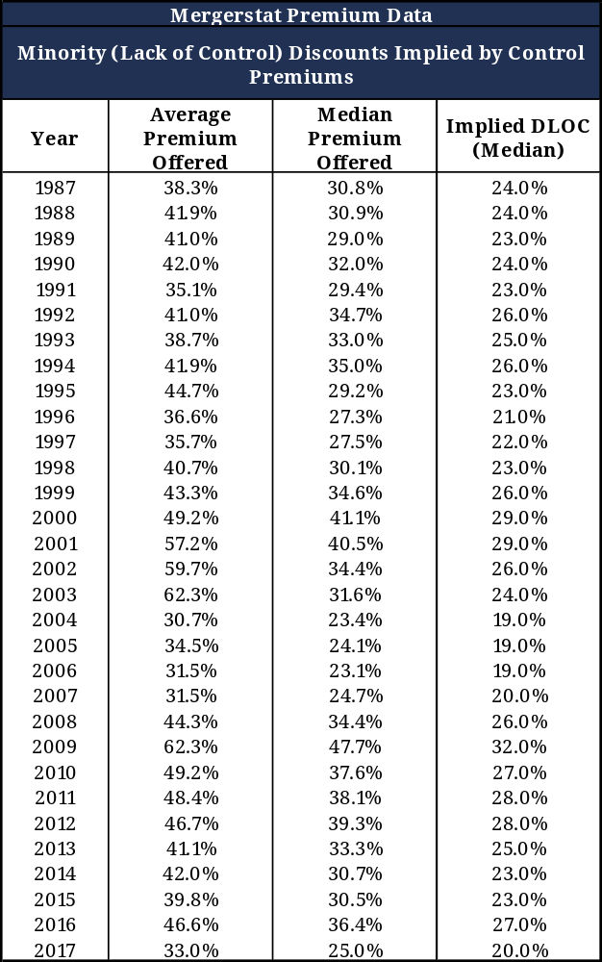
Houlihan, Lokey, Howard & Zukin’s Control Premium Study provides a similar type of analysis but attempts to overcome any potential data distortions attributable to stock price run-ups resulting from speculative anticipation of a possible transaction by showing minority stock prices one day, one week, one month and two months before the announcement date. Further, the Control Premium Study reviews only cash tender transactions, which reduce the size of the data pool somewhat, but provide us with a “cash equivalent” price to help determine the fair market value of the appraisal subject by making the comparative premiums/discounts more applicable to the definition of value assumed herein.

The Control Premium Study evidences discounts somewhat higher than the Mergerstat studies, with premiums ranging over the past several years from 5 to 10 percentage points over Mergerstat, which translates to minority discounts of 25 to 35 percent.

Qualitative Analysis
Finally, we reviewed the ownership characteristics of the subject interest, as well as the ownership structure, shareholders agreement, and state statutes relating to ownership control relevant to the subject interest as available. In this instance, the shareholders agreement does not limit this interest beyond its percentage interest influence. We then considered the relative degree of control the subject interest has relative to a controlling interest, based upon the prerogatives of control previously defined.

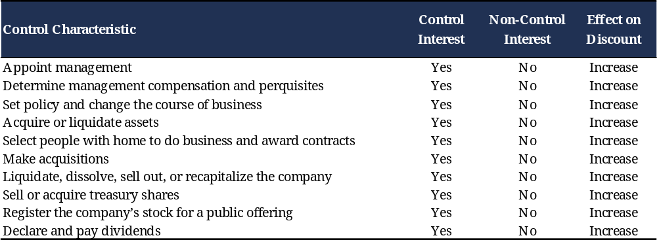

The empirical evidence provides strong support for non-control interest discounts, but within a wide range, from a low of 19 percent to a high of 40 percent. While the qualitative analysis cannot provide a statistical tool from which we can pinpoint an exact discount within the range, we believe that the lack of control evident to a minority interest in the prerogative analysis argues for a discount at the higher end of the range.

We considered the construct of the Company as compared the non-control interests of similar entities traded in the secondary markets and believe they provide a strong indicator as to an appropriate discount for the lack of control prerogatives. For example, the Mergerstat Control Premium Studies provide an implied lack of control discount with a central tendency of approximately 20 percent.

Typical public company stock sales are transactions involving minority interests. On occasion, a controlling block of shares in a public company is acquired the acquirer usually has to offer a premium to induce a large number of shareholders to sell their shares of company stock. Using Capital IQ, we searched for control premiums in xyz Corp’s industry.

The results of our search are provided below. Each of these transactions has its own individual control premium, defined as the difference between the price offered per share and the share price one month prior to the announcement of the transaction.

PLACE CONTROL PREMIUM TABLES HERE (CENTERED)

APPENDIX J: DISCOUNT FOR LACK OF MARKETABILITY
Marketability is defined in the International Glossary of Business Valuation Terms as “the ability to quickly convert property to cash at minimal cost.” Some texts go on to add “with a high degree of certainty of realizing the anticipated amount of proceeds”. DLOM is “an amount or percentage deducted from the value of an ownership interest to reflect the relative absence of marketability.”

Given two identical business interests, a higher price will be paid by investors in the market for the business interest that can be converted to cash most rapidly, without risk of loss in value. An example is publicly traded stock on the New York Stock Exchange, where the owner can order the sale and the proceeds are deposited in a bank account in three days.

In the alternative, a lesser price is expected for the business interest that cannot be quickly sold and converted to cash. A primary concern driving this price reduction is that, over the uncertain time frame required to complete the sale, the final sale price becomes less certain and with it a decline in value is quite possible. Accordingly, a prudent buyer would want a discount for acquiring such an interest to protect against value loss in a future sale scenario.

Naturally, assets which are difficult to sell are worth less than those that can rapidly and cheaply be converted into cash at a reasonable price. Thus, the absence of liquidity lowers the value of the asset by the amount of the liquidity discount. Across most asset classes, investors are willing to pay a premium for assets that are more liquid.

To derive the discount for lack of marketability in this case, we applied the two most preferred methodologies for emerging growth companies, the Protective Put Approach and Asian Put Approach. In the Protective Put Approach (Chaffee Model) the cost of a put option calculated ‘at the money’ acts as an estimate for the discount for lack of marketability. In the Asian Put Approach (Finnerty Model) the marketability discount could be approximated by the value of an “average-strike” (aka “Asian”) put option. The value of the put option in both the cases has been calculated using the Black-Scholes option-pricing model.

In the Protective Put Approach, a put option provides a buyer the right but not the obligation to sell the investment held by him at the strike price of the put option. By purchasing a put option, the buyer ensures the liquidity of his investment as he now has the right to sell the investment at the strike price of the put option. This cost of the put option becomes the implied discount for an investor holding stock of a privately held firm, as this stock lacks marketability. Thus, by calculating the value of a put option at a strike price equal to the value of the underlying stock, we can estimate the discount for lack of marketability. This is then deducted from the value of the underlying stock to arrive at the fair market value.

In the Asian Put Approach, an average-strike put conveys the right to sell at the average price attained by the subject shares during the life of the option. The model works under the assumption that investors have no special ability to time the market. If investors cannot time the market, the restriction has the effect of depriving them of average (not maximum) trading profits.

The application of the Protective Put Method and the Asian Put Method is presented in the table below:

PLACE COMMON VOLATILITY TABLE HERE (CENTERED)

PLACE DLOM TABLE HERE (CENTERED)

APPENDIX K: DISCOUNT FOR LACK OF VOTING RIGHTS
If a company has both voting and nonvoting stock, the voting stock may be worth more than the nonvoting stock because of the value of voting rights. For small non-controlling interests, this differential is usually small. Most states and company articles of incorporation do not guarantee nonvoting (or other non-controlling) shareholders the same per share price (or any offer at all) if a controlling block is sold. There have been many transactions in which control blocks have sold at substantial premiums over offers to other stockholders.

In the publicly traded equity marketplace, there is a relatively small number of “paired” securities - voting and nonvoting shares that are in all other respects identical - in the public market. Their day-to-day pricing is inconclusive as evidence of a value differential attributable to the right to vote. Several studies have been conducted over the last 30 years attempting to measure the incremental difference between voting and nonvoting shares as follows.:
- Lease, McConnell and Mickkelson. The analysis covered the period from 1940 through 1978 and included 26 corporations with two classes of common stock. The voting and nonvoting shares had equivalent dividend and liquidation preferences and were actively traded on the public market. This study found that the premium for voting stock averaged 5.4 percent, which corresponds to a discount for lack of voting rights of 5.2 percent.
- O’Shea and Siwicki. This 1991 study included 46 US companies with publicly traded voting and nonvoting stock. Importantly, the authors concluded that the nonvoting shares of all but six of the companies had superior dividend or liquidation rights, which, they asserted, compensated for inferior voting rights. The median premium paid for voting shares equaled 1.3 percent, which corresponds to a discount for lack of voting rights of 1.3 percent.
- Smith and Amoako-Adu. In this 1995 analysis, the prices of voting and nonvoting shares of Canadian companies, which were actively traded on the Toronto Stock Exchange between 1981 and 1986 and between 1988 and 1992, were compared. The median voting premiums were 4.2 percent for the first period and 6.4 percent for the second period. These premiums correspond to discounts for lack of voting rights of 4.0 percent and 6.0 percent, respectively.
- Cox and Roden. This 2002 study included 98 companies with two classes of common stock trading from 1984 to 1999. The observed premiums for voting rights are higher than in other studies, and vary depending on the form of dividend promise to the low- or non-voting shareholders. The study found that firms promising equal dividends to both classes average an 11.1 percent premium for voting rights. Firms promising preferential dividends for low- or non-voting shares average a 3.8 percent premium for voting rights. The corresponding discounts for lack of voting rights is 9.0 percent and 3.7 percent, respectively.
- Houlihan, Lokey, Howard, and Zukin. This study was published in 1996, and included 116 companies having voting and nonvoting stock with similar dividend rights and/or liquidation preferences. The median voting premium ranged from 1.2 percent for the 60-day moving average to 2.8 percent for the 260-day moving average. These premiums correspond to discounts for lack of voting rights of 1.1 percent and 2.8 percent, respectively.
- Deloitte DTBA Research. In an unpublished study, for the purpose of gauging the implied discount for lack of voting rights, Deloitte identified and compared companies with voting and nonvoting classes of common stock publicly traded on any of the major US Exchanges. In its analysis, Deloitte also included companies with significant voting power differences between each class of publicly traded stock. To quantify the implied discount for lack of voting, Deloitte determined the difference in stock price between the voting (or superior voting) and nonvoting (or inferior voting) class categories for various periods of time. Deloitte calculated the average and median on a daily basis for a period of three months, six months, and twelve months and calculated the average and median on a weekly share price basis for three years, 5 years, and 10 years. Deloitte excluded from this calculation any implied premiums, as it considered them to be company specific abnormalities. The results are summarized in the table below.

Measurement Period | Effective Date | 3 Month | 6 Month | 12 Month | 3 Year | 5 Year | 10 Year
Average | 6.0% | 7.5% | 7.7% | 6.8% | 6.4% | 4.7% | 5.2%
Median | 2.9% | 4.7% | 5.0% | 5.0% | 3.8% | 2.7% | 2.3%
Company Count | 13 | 12 | 12 | 13 | 9 | 11 | 12

Based on this market-derived evidence, we concluded that a relatively small 5 percent discount for lack of voting rights (“DLOV”) was appropriate for the nonvoting equity interests of the Company.

APPENDIX L: SOURCES OF INFORMATION
Oxford Valuation Partners spoke with the following person(s):

Contact Name, Position at FULL LEGAL NAME incl. d/b/a

Information provided by Management included the following:

- Audited and (REMOVE “AUDITED AND”) IF NO AUDITED FINANCIALS PROVIDED) unaudited historical financial statements.
- The Company’s Articles of Incorporation and other corporate documents.
- Various marketing materials, reports and analyses prepared by Management including information presented on the Company's web site.
- Board presentations and financial updates.
- The Company’s most recent capitalization table, as of the Valuation Date.

In addition, we consulted the following sources, among others:

- Standard & Poor’s Capital IQ Database (www.capitaliq.com)
- Kroll’s Cost of Capital Navigator.
- A Task Force of the AICPA. Valuation of Privately-Held-Company Equity Securities Issued as Compensation. AICPA. 2011.
- AICPA “Statement on Standards for Valuation Services No. 1 – Valuation of a Business, Business Ownership Interest, or Intangible Assets”, AICPA, 2007.
- Internal Revenue Manual Business Valuation Guidelines, IRM 4.48.4, Engineering Program, Business Valuation Guidelines” (July 27, 2006).
- “Accounting and Valuation Guide – Valuation of Portfolio Company Investments of Venture Capital and Private Equity Funds and Other Investment Companies,” AICPA, 2019.

Revenue Ruling 59-60, 1959-1, C.B. 237.
Ibid.
Financial Accounting Standards Board (“FASB”) Accounting Standards Codification (“ASC”) Topic 820, Fair Value Measurement (“ASC 820”).
This is in accord with the American Institute of Certified Public Accountants (“AICPA”) Practice Aid, “Valuation of Equity Securities in Complex Capital Structures” section 6.35, which states that in general, because the OPM considers the evolution of the equity value without allowing for proceeds raised in additional financings, the allocation does not include the dilution impacts of any additional financings, nor the dilution impacts of any options and warrants that may be issued as the company progresses toward a future liquidity event. That is, even if the company has reserved a pool of options that may be issued to new and existing employees as the company progresses toward a successful liquidity event, only outstanding options and options that will be issued in the short term, irrespective of any changes in the company's value, are included in the allocation.
As discussed in Section 2.1, “near term” has been defined as the sooner of 12 months or until the date of the Company’s next financing.
Source: Global Economic Prospects, World Bank Group, January 2024.
Source: OECD Economic Outlook, OECD, Volume 2023 Issue 2.
Source: CITE YOUR SOURCE(S)
Internal Revenue Manuals 4.48.4, Business Valuation Guidelines.
AICPA, Valuation of Privately-Held-Company Equity Securities Issued as Compensation, Chapter 5, paragraph 45.
Ibid. at Chapter 6, paragraph 53.
For the guideline public companies, BEV is the sum of the market capitalization as of the Valuation Date and total debt (excluding leases), less cash and equivalents.
For the guideline public companies, BEV is the sum of the market capitalization as of the Valuation Date and total debt (excluding leases), less cash and equivalents.
This last point is only applicable in the case of non-participating preferred shares.
This last point is only applicable in the case of non-participating preferred shares.
AICPA Valuation of Privately-Held-Company Equity Securities Issued as Compensation, Chapter 6, paragraph 55.
Ibid. at Chapter 8, paragraph 8.
Ibid. at Chapter 8, paragraph 12.
International Glossary of Business Valuation Terms, as adopted in 2001 by American Institute of Certified Public Accountants, American Society of Appraisers, Canadian Institute of Chartered Business Valuators, National Association of Certified Valuation Analysts, and The Institute of Business Appraisers.
Shannon P. Pratt, Alina V. Niculita, Valuing a Business, The Analysis and Appraisal of Closely Held Businesses, 5th ed (New York: McGraw Hill, 2008), p.39.
International Glossary.
Ronald C. Lease, John J. McConnell and Wayne H. Mikkelson, “The Market Value of Differential Voting Rights in Closely Held Corporations.” The Journal of Business, Vol. 57, No. 4 (Oct., 1984): pp. 443-467.
Keven C. ‘Shea and Robert M. Siwicki, “Stock Price Premiums for Voting Rights Attributable to Minority Interests.” Business Valuation Review (December 1991): pp. 165-171.
Smith, Brian F. and Ben Amoako-Adu, “Relative Prices of Dual Class Shares,” Journal of Financial and Quantitative Analysis, Vol. 30, No. 2, June 1995, pp. 223-239.
Steven R. Cox and Dianne M. Roden, “The Source and Value of Voting Rights and Related Dividend Promises,” Journal of Corporate Finance, Vol. 8, 2002, pp. 337-351.
Paul J. Much and Timothy J. Fagan, “The Value of Voting Rights,” in Financial Valuation: Business and Business Interests, 1996 Update, James H. Zukin, ed. (New York: Warren Gorham & Lamont, 1996).
The Capital IQ platform is a web and Excel-based research product that combines deep information on companies and markets worldwide with robust tools for fundamental analysis, idea generation, and workflow management. Capital IQ is deployed at leading investment banks, fund managers, private capital firms, and corporations. Capital IQ provides the infrastructure and data to analyze company fundamentals, create charts/reports, and build various financial models for comparable analysis, valuation analysis, transaction scenarios, and various other situations.

